IRCHESTER PARISH COUNCIL

Minutes of the Ordinary Meeting of the Parish Council held on Wednesday 22nd February 2023 at the Village Hall, School Road at 7.15p.m.

Members Present:
P Armstrong– In the Chair

Councillors
P Smith L Brown JP Carr T Maguire S Bridge K Watts
C Ashford M May S East D Shroll S Vassell V Blake

The meeting started at 7.15pm. there were 20 members of the public present.

Apologies - Agreed and Accepted from Cllrs J Dunkley and Cllr K Clarke

22/92 Public Questions, Police Report and NNC Update

Standing Orders were suspended to allow a further 15 minute public session

Public: Concern was raised from the public for the following:

- Tree growth hindering visibility for drivers
- Parking on zig zag lines on the crossings, yellow lines and junctions
- Asked the Council to make a further request to have a post box in the centre of the village
- Accidents and mobile police cameras asking for more police presence and enforcement
- Traffic calming working party to meet asap and work with the public to have measures put in place
- Extra crossings

Standing Orders were resumed

Police Report – details sent to councillors

NNC Report – Information had been sent to Councillors from NNC Leader regarding projects ongoing with North Northants Council. These included some community funding grants, tourist hub at Rushden Lakes, Mental Health Week and the Boundary Commission Review. Question was asked that the problem with fly tipping should be raised and addressed at the next NNC meeting.

22/93 Notification of Any Interests

None declared

22/94 Minutes

The minutes from 25th January 2023 were agreed as a true record to be signed by the Chair.

22/95 Financial Matters

- Payments – Resolved: That the payments for £8532.86 for February 2023 were approved.

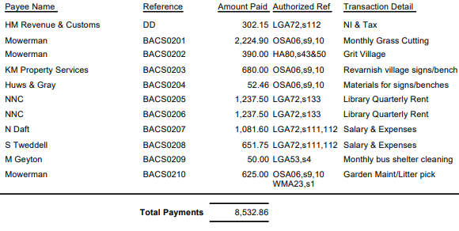

- The Current financial statement after the payments being £187,623.71
- RESOLVED that Cllrs L Brown and P Armstrong to authorise the bacs payments for February 2023
- A Grant funding application from the Irchester Players had been received. It was RESOLVED to grant £1900 as requested to the Irchester Players in order to help support the youth group and further productions.

22/96 Cemetery/War Memorial

- There had been an issue with a damaged headstone and a lessee asking if they cut the grass around the plot instead of the councils contractor. This to be monitored.
- Wreaths around the War Memorials to be removed.

22/97 Highways

- Highways issues – A meeting had been held with residents, highways and the police regarding several issues with speeding and parking within the village. It was agreed to set up a Working Party with Councillors and residents in order to make recommendations to full council and highways in order to help resolve the problems. It was agreed that Cllrs S Bridge, T Maguire, JP Carr, L Brown and V Blake sit on the Working Party. A meeting to be arranged asap. It was also suggested to write to the Police and Crime Commissioner to notify them of the Working Party as also ask what monies may be available for traffic highway safety.
- A request was made for a further litter bin to be placed in Wollaston Road near to the War Memorial however, it was felt that the area already had sufficient bins. Suggestion was made to write to Wollaston School to ask children waiting for the school bus to use the bins in order to help with the litter problem.

22/98 Play Areas
- The order for the new play equipment for Little Irchester Daniels Road had been ordered. Installation date TBC.
- As money was being donated by the now dissolved 1-100 club for some of the new equipment they have asked for a plaque to be place on the fence. RESOLVED to accept the wording as ‘This equipment was paid for from the donation made by the Little Irchester 1-100 Club (1976-2016)’ and order a plaque when the equipment was installed.

22/99 Community Projects

- Orchard – approximately 120 daffodil and tulip bulbs and 8 trees had been planted with further bulbs to be added. The damaged tree had also been repaired. Due to the lack of rain the water butts were only a quarter full so water would need to be taken to site for later in the year.
- Village Voice – it was noted that 2 of the 3 distribution people had decided not to continue to help with the magazine in future. The March production was ready to send to the printers and it was agreed for this production that the magazine would be delivered to the library, sorted and distributed by several councillors.
- Library –.2 new volunteers had been trained. There had been 435 visitors to the library since opening in October. A donation of £50 had been received and a further £850 donation was pending. Rhyme time was successful will approximately 30 attendees at each session. Volunteers had had a meeting to discuss details in the library and funding raising ideas.
- King Charles III coronation – the bench seat design had been given to councillors and it was RESOLVED not to proceed with the coronation bench but to look for an alternative seat which could incorporate a plaque.
- Discussion took place regarding organising a brain storming session with councillors to determine what they felt was needed in the village within the next 5 years. A meeting to be set up in the late spring/summer.

22/100 Correspondence

- NW/23/00089/FUL – Conversion of agricultural buildings into 5 dwellings – Irchester Grange Farm – A re submission of the planning application had been received however if was felt that further information was required from the statutory consultees before further comment from the parish council could be made.
- Details had been received regarding new energy tariff costs as the fixed term rate ends on 31st March 2023.It was agreed to add this to the March agenda for further discussion.

Meeting closed at 9.03 pm

Chair

