IRCHESTER PARISH COUNCIL

Minutes of the Ordinary Meeting of the Parish Council held on Wednesday 26th June 2024 at the Village Hall, School Road at 7.15p.m.

Members Present:
K Watts – In the Chair

Councillors
P Armstrong A Hurley J-P Carr A Howden M May S East
P Smith B Leeson D Schroll G Brotherston J Dunkley

The meeting started at 7.15pm. There were 2 members of the public present & NNC Cllr T Partridge Underwood.(TPU)

Apologies - All in attendance

24/16 Notification of Any Interests

None declared

24/17 Public Questions, Police Report and NNC Update

Public – No questions raised

Police – report sent to councillors.

NNC Update – Leaders report sent to councillors.

24/18 Minutes

RESOLVED - The minutes from 29th May 2024 meeting were agreed as a true record and signed by the Chair.

24/19 Co-option

RESOLVED to co-opt Mr Macdonald to the Council. Acceptance of Office was signed.

24/20 Financial Matters

- Payments – RESOLVED: That the payments for £6700.34 for June 2024 were approved. Directs Debit payments pending Yu Energy, Hugo Fox, Wave

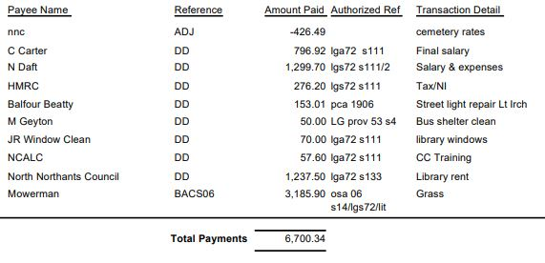

- The Current financial statement after the payments, but not including the DD’s, being £268,676.76
- RESOLVED that Cllrs JP Carr & P Smith to authorise the bacs payments for June 2024.
- Details of the budget to date were given to councillors and will be reviewed again in September.

24/21 Recreation Grounds

- Fair in attendance, health and safety checked, no issues recorded
- Discussion took place regarding the maintenance of the metal fencing and it was agreed to obtain a quotation to have the gate and posts painted. Clerk was given delegated powers to arrange for works to be carried out up to the value of £750
- Discussion took place regarding the ground and the key holders of the gate. It was suggested that a more formal agreement with the Romans football team be in place of which the pc representatives will discuss with the Sports Association. The representatives were also asked for a list of key holders for the recreation gate
- Discussion took place regarding a tribute to the late Cllr Maguire. Several suggestions were made regarding the sports club of which the council representatives will suggest at the next Sports Association meeting.

24/22 Highways

- It was noted that a new issues had been reported to fixmystreet regarding weeding of gullies and side road which had been taken down by them and re reported
- Discussion took place regarding replacing the seat at the corner of Bakers Crescent. It was suggested that further information is required regarding the payment of the seat for the next meeting.
- It was stated that one of the old VAS signs was now broken and a new set of batteries was required. It was RESOLVED to purchase a set of new batteries and to add the cost of a new VAS sign to the September agenda.
- The metal structure of the bench by the water tower had been taken and currently there was no other seat available to replace it.

24/23 Cemetery/War Memorial

Request had been raised by an adjoining land owner to remove part of the cemetery metal fencing. RESOLVED not to allow the resident to remove the fence.
Discussion took place regarding volunteers from the veteran community being allowed to tidy the Irchester War Memorial. It was agreed in principle however a risk assessment would need to be put in place. Cllr Smith asked for his vote to abstain be recorded.

24/24 Planning

- NW/24/00322/FUL Use of the car par at Irchester Sports and Social Club, every Saturday and Sunday from 10.00 - 17.00, for the siting of a mobile van to facilitate the selling of hot food (Sui Generis) Location: Recreation Ground Alfred Street Irchester – No objections
- NW/24/00331/FUL - whereas the pc welcome new cottage industries starting up they are concerned regarding the impact that parking would have in the area especially at school times where there is already limited access. This is in respect of policy 8 of the Local Plan.

24/25 Village Magazine

Discussion took place regarding the naming of the magazine and how it had been changed. It was stated that the working party should have advised the full council of the recommendation before the changes were made.

24/26 Correspondence

Cllr JP Carr declared an other interest as her is a NNC councillor

- An open letter regarding Kettering Energy Park had been received and noted.

24/27 Exclusive to Public and Press

RESOLVED: That pursuant to the Public Bodies (Admission to Meetings) Act 1960, the public and press is excluded from the meeting for the item of business on the grounds that publicity would be prejudicial to the public interest by reason of the confidential nature of the business to be discussed.

24/28 Staff

Details of the advertisement and job description for the new clerk were discussed and it was agreed to advertise asap with NCALC

Meeting closed at 9.05 pm

Chair

These minutes are draft until agreed at the next full council meeting

