
The Parish Council of Irchester
Clerk  Nikki Daft MILCM  45 Park Road  Irthlingborough  Northants  NN9 5PW |  | Telephone 01933 384180  Parishclerk123@gmail.com

Dear Councillor 21st March 2016

You are hereby summoned to attend the Ordinary meeting of Irchester Parish Council to be held at Hilton Hall, Little Irchester on Wednesday 30th March 2016 at 7.15p.m.

Yours faithfully
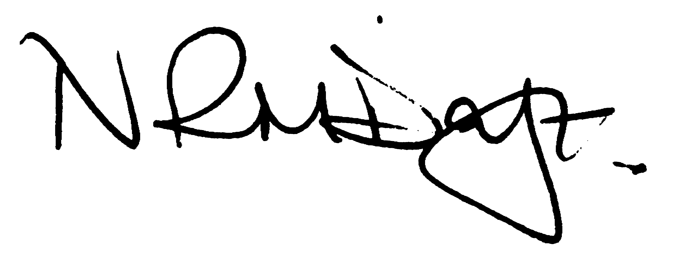

Nikki Daft – Parish Clerk

Guest Speaker – Bob Wade from Nene Valley First Responders giving a talk and demonstration on a defibrillator and details regarding safe email and website usage

AGENDA

APOLOGIES AND ACCEPTANCE OF APOLOGIES

15/112 NOTIFICATION OF ANY DISCLOSABLE PECUNIARY INTERESTS OR OTHER INTERESTS
Only in respect of matters which are to be considered by members below. (Disclosures previously declared and registered need not be repeated).
• To receive written requests for dispensations for disclosable pecuniary interests (if any)
• To consider any requests for dispensations as appropriate

15/113 MINUTES

a) To approve the minutes of the meetings held on 24th February 2016 as true records

15/114 PUBLIC QUESTIONS, POLICE REPORT AND NCC UPDATE

Public participation may continue until for 15 minutes after which the public must not take part at any other time during the meeting. Please note that the meeting maybe recorded. All audible sounds to be switched to silent unless otherwise agreed at the start of the meeting. A report only can also be given by the Police and NCC representatives

15/115 RESOLUTIONS AND ACTIONS - MATTERS FROM PREVIOUS MINUTES
Agenda | Task | By | Completed/comments
Feb | Grass mats Poached areas in play grounds | Clerk | To be ordered
 | Play equipment review | Rec Grp | To organise
 | Procurement procedures | Fin Grp | Meeting 2 March
 | Parking School Road/Lane | Cllrs | Monitor after works completed
 | Letter to youth re speech | Clerk | Emailed 26 feb
 | Flags | Clerk | Ordered
 | Preschool funding | Clerk | Email sent 25th Feb
 | Highways Station Road | TM
 | Wollaston School competition letter | Clerk | Emailed 25th Feb
 | Best village competition form | Clerk | Sent 15th March 2016
 | Response NNJCS | Clerk | Letter 25th Feb
 | Planning response | Clerk | Emailed 25th Feb
Street light vegetation reported 15th March 769685

15/116 FINANCIAL/POLICIES

- To Approve Payments for March 2016 (Clerk)
- To receive information regarding the current financial statement (Clerk)
- To agree the authorisation of the bacs payments
- To discuss the request for grant funding for the Neighbourhood Watch
- To discuss the funding of £3900 for the School Patrol Crossing person
- To review the Standing Orders, Financial Regulations and Audit regulations

15/117 RECREATION GROUNDS

- To receive and agree the reports/repairs/damage to the recreation grounds
- To discuss the cost to remove the concrete area at the entrance to Austin Close
- Proposal – A proposal has been made that the parish council of Irchester agree, in principle, to allow vehicular access over the Austin Close play area in order for development to take place in conjunction with the NHP stage 2 consulation outcome.
- To look at Denton Close play area and discuss ways to improve the site.

15/118 HIGHWAYS

- Street Doctor updates 769685 – vegetation obstruction light in High Street – Referred to E Ymeri
- To receive information regarding litter in Arkwright Road and what course of action the pc may take
- To discuss the requirement of the NCC Enhancement Gang – sign cleaning etc
- To discuss the problem with the light in the alleyway from School Road and if the council wish to pay for the trunking in order to have power installed
- To discuss the purchasing of a Vehicle Activated Sign for the Station Road area due to the amount of accidents being reported and review the comments from NCC highways

15/119 LITTLE IRCHESTER/KNUSTON

- To agree the Highway Warden report. Matters arising will be added to the next agenda
- Street Doctor – 769791 drain cover Little Irchester roundabout – work instructed
- To discuss the problem with the 2 Rowan Trees as per resident information.

15/120 PLANNING

To receive an update on planning matters

- WP/16/00121/OUT - Application for outline planning permission with some matters reserved for residential development of 2No single storey dwellings (access to be determined at this stage) Location: 94 And Annex Farndish Road, Irchester
- WP/16/00133/VAR – Variation of permission WP/15/0200 – Land opp 7-11 Claudius Way

15/121 NEIGHBOURHOOD PLAN

- To receive an update on the NH Plan

15/122 CEMETERY/WAR MEMORIAL

- Registrar report – matters for next agenda

15/123 COMMUNITY

- To discuss the production of the Village Voice ready for printing and who will complete the work
- Update on the Best Village Competition
- To discuss the production of a Village Welcome Leaflet
- To discuss the possibility of a defibrillator for the village, funding and housing
- To receive information from the school regarding the litter poster competition

15/124 CORRESPONDENCE

To consider information received from incoming correspondence and decide on agenda items for the next meeting

- To discuss if the council wishes to purchase commemorative coins to celebrate the Queens 90th birthday.
- Northants County Council Amendment to 2015 Permit Scheme
- Invite to St Katherines for 2 representatives To the collation by the Bishop of Brixworth and induction by the Archdeacon of Northampton of the Reverend C Lomas
- Anglian Water Prevent Pollution Scheme

