
The Parish Council of Irchester
Clerk  Nikki Daft MILCM  45 Park Road  Irthlingborough  Northants  NN9 5PW |  | Telephone 01933 384180  Parishclerk123@gmail.com

Dear Councillor 17th August 2015

You are hereby summoned to attend the Ordinary meeting of Irchester Parish Council to be held at Village Hall School Road Irchester on Wednesday 26th August 2015 at 7.15p.m.

Yours faithfully
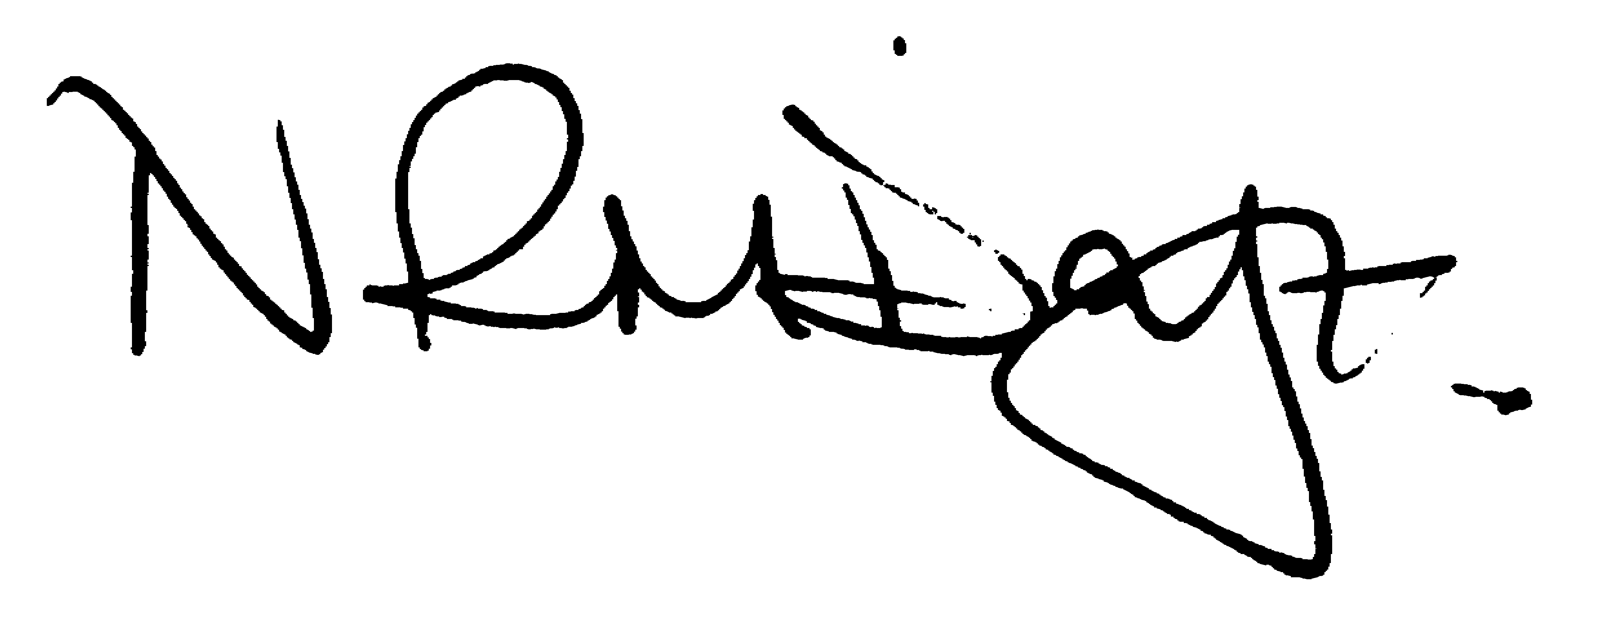

Nikki Daft – Parish Clerk

AGENDA

APOLOGIES AND ACCEPTANCE OF APOLOGIES

15/32 NOTIFICATION OF ANY DISCLOSABLE PECUNIARY INTERESTS OR OTHER INTERESTS
Only in respect of matters which are to be considered by members below. (Disclosures previously declared and registered need not be repeated).
• To receive written requests for dispensations for disclosable pecuniary interests (if any)
• To consider any requests for dispensations as appropriate

15/33 MINUTES

a) To approve the minutes of the meetings held on 24th June 2015 as true records

15/34 PUBLIC QUESTIONS, POLICE REPORT AND NCC UPDATE

Public participation may continue until for 15 minutes after which the public must not take part at any other time during the meeting. Please note that the meeting maybe recorded. All audible sounds to be switched to silent unless otherwise agreed at the start of the meeting. A report only can also be given by the Police and NCC representatives

15/35 RESOLUTIONS AND ACTIONS - MATTERS FROM PREVIOUS MINUTES
Agenda | Task | By | Completed/comments
90/101/13 | Quotes re land registry | Clerk | Ongoing
8797//13 | Dog Fouling | Cllrs | Monitor
106/13 | Sign fly posting | Cllrs | To monitor
14/112 | Unmetered suppliers | Clerk | On going
14/130 | Cemetery rules | cllrs | Aug meeting
 | Freedom of Information, So’s & Fin Regs | Cllrs | Aug Meeting
15/22 | Cost to have seat nr crossing re sited | Clerk | Agenda item
 | Letter re headstone/cremated remains query | Clerk | 25/6/15
15/25 | Letter R West & Sports Ass | Clerk | 25/6/15
 | Quote cans only bin | Clerk | Agenda item

15/36 FINANCIAL/POLICIES

- To Approve Payments for July and August 2015 (Clerk)
- To receive information regarding the current financial statement (Clerk)
- To agree the authorisation of the bacs payments
- To receive the report from the External Auditor
- To receive and update on unmetered supply costs (Clerk)
- To review Freedom of Information Policy, Standing Orders, Financial Regulations, Risk Assessment & Internal Audit Controls
- To agree a date for the next finance meeting
- To discuss the setting up of a facebook information page

15/37 RECREATION GROUNDS

- To receive and agree the reports/repairs/damage to the recreation grounds (JD)
- To discuss the smooth surface of the skatepark and determine if there is anything available to make the tracking on the surface better
- To receive information regarding the moving of the bench next to the zebra crossing
- To receive a quotation for a cans only bin at Austin Close

15/38 HIGHWAYS

- To discuss the possibility of installing a litter bin in Bradshaw Way

15/39 LITTLE IRCHESTER/KNUSTON

a) To agree the Highway Warden report, previously circulated. Matters arising will be added to the next agenda

15/40 PLANNING

To receive an update on planning matters

WP/2015/00473/FUL – Demolition of bungalow and erection of replacement dwelling – 203 Wollaston Road
WP/2015/00492//FUL – Construction of timber porch Station House Irchester

15/41 NEIGHBOURHOOD PLAN

- To receive an update on the NH Plan

15/42 CEMETERY

- To review the Cemetery Rules and Regulations with the addition of the cremated remains plot size
- To discuss the Autumn/Winter planting for the cemetery and War Memorial and agree the cost of £100.00

15/43 ORGANISATION REPORTS/SUGGESTIONS

- To receive a report regarding the issues with the library (RE)
- To receive a report from the Youth Club latest meeting
- To discuss the poor parking in the Village Hall car park and what remedial action could be taken

15/44 CORRESPONDENCE

To consider information received from incoming correspondence and decide on agenda items for the next meeting.

