
The Parish Council of Irchester
Clerk  Nikki Daft MILCM  45 Park Road  Irthlingborough  Northants  NN9 5PW |  | Telephone 01933384180  Parishclerk123@gmail.com

Dear Councillor 22nd August 2016

You are hereby summoned to attend the Ordinary meeting of Irchester Parish Council to be held in the Hilton Hall Little Irchester on Wednesday 28th September 2016 at 7.15p.m.

Yours faithfully
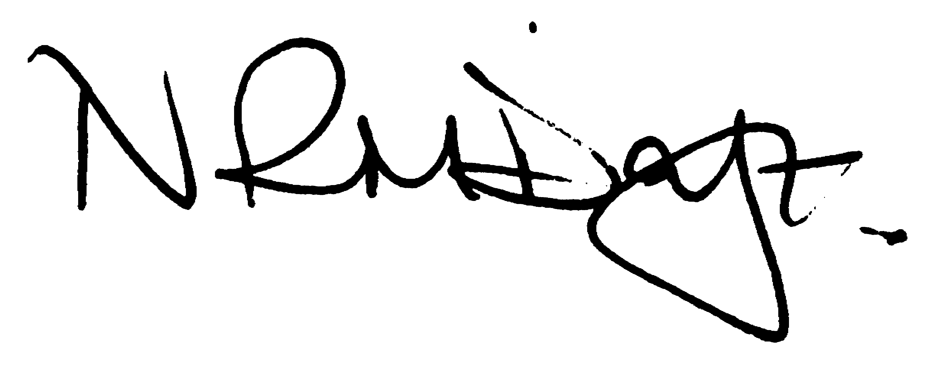

Nikki Daft – Parish Clerk

AGENDA

APOLOGIES AND ACCEPTANCE OF APOLOGIES

16/51 NOTIFICATION OF ANY DISCLOSABLE PECUNIARY INTERESTS OR OTHER INTERESTS
Only in respect of matters which are to be considered by members below. (Disclosures previously declared and registered need not be repeated).

16/52 PUBLIC QUESTIONS, POLICE REPORT AND NCC UPDATE

Public participation may continue until for 15 minutes after which the public must not take part at any other time during the meeting. Request should be made to the Chair if any member of the public wishes to make a recording of any part of the meeting. All audible sounds to be switched to silent unless otherwise agreed at the start of the meeting. A report only can also be given by the Police and NCC representatives

16/53 MINUTES

- To approve the minutes of the meetings held on 31st August 2016 as true records

16/54 RESOLUTIONS AND ACTIONS - MATTERS FROM PREVIOUS MINUTES

16/55 FINANCIAL/POLICIES

- To Approve Payments for September 2016 (Clerk)
- To receive information regarding the current financial statement (Clerk)
- To agree the authorisation of the bacs payments
- To receive information regarding additional bank account details.

16/56 RECREATION GROUNDS

- To receive and agree the reports/repairs/damage to the recreation grounds (JD)
- To receive further information regarding the cutting back/removal of the sycamore tree to a safe height on the recreation ground
- To receive information regarding the setting of a byelaw

16/57 HIGHWAYS

- To agree any items that need to be added to the next agenda
- To receive information regarding the TR22 lighting inspection
- To receive ideas in organising a litter picking group throughout the village

16/58 LITTLE IRCHESTER/KNUSTON

- To agree the Highway Warden report, previously circulated. Matters arising will be added to the next agenda

16/59 PLANNING

16/60 NEIGHBOURHOOD PLAN

- To receive an update on the progress of the NHP

16/61 CEMETERY/WAR MEMORIAL

- To receive the Registrars report, previously circulated, and decide if details should be added to the next agenda

16/62 COMMUNITY

16/63 CORRESPONDENCE

To consider information received from incoming correspondence and decide on agenda items for the next meeting.

