
The Parish Council of Irchester
Clerk  Nikki Daft MILCM  45 Park Road  Irthlingborough  Northants  NN9 5PW |  | Telephone 01933 384180  Parishclerk123@gmail.com

Dear Councillor 15th June 2015

You are hereby summoned to attend the Ordinary meeting of Irchester Parish Council to be held at Village Hall School Road Irchester on Wednesday 24th June 2015 at 7.15p.m.

Yours faithfully
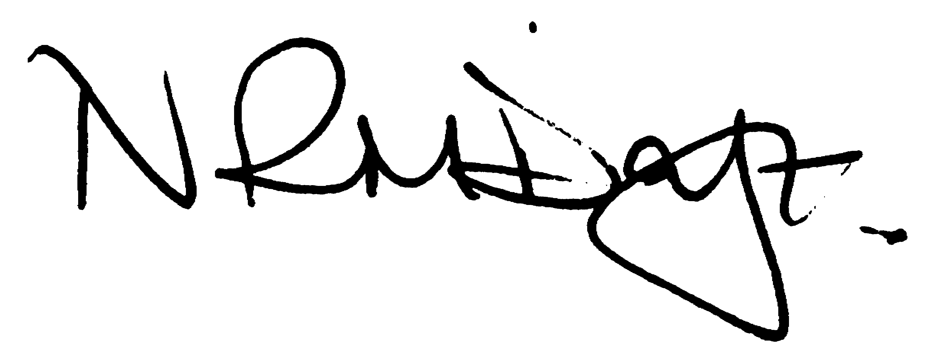

Nikki Daft – Parish Clerk

AGENDA

APOLOGIES AND ACCEPTANCE OF APOLOGIES

15/20 NOTIFICATION OF ANY DISCLOSABLE PECUNIARY INTERESTS OR OTHER INTERESTS
only in respect of matters which are to be considered by members below. (Disclosures previously declared and registered need not be repeated).

15/21 MINUTES

a) To approve the minutes of the meetings held on 20th May and 3rd June 2015 as true records

15/22 PUBLIC QUESTIONS, POLICE REPORT AND NCC UPDATE

Public participation may continue until for 15 minutes after which the public must not take part at any other time during the meeting. Request should be made to the Chair if any member of the public wishes to make a recording of any part of the meeting. All audible sounds to be switched to silent unless otherwise agreed at the start of the meeting. A report only can also be given by the Police and NCC representatives

15/23 RESOLUTIONS AND ACTIONS - MATTERS FROM PREVIOUS MINUTES
Agenda | Task | By | Completed/comments
90/101/13 | Quotes re land registry | Clerk | Ongoing
8797//13 | Dog Fouling | Cllrs | Monitor
106/13 | Sign fly posting | Cllrs | To monitor
14/112 | Unmetered suppliers | Clerk | On going
14/130 | Cemetery rules | cllrs | June meeting
15/12 | New signatories | Cllrs | Next meeting
 | SO, Fin Regs etc | Cllrs | August meeting
 | Safety surface VH | Cllrs | Look at funding June Meet
15/13 | Letter King West re copy of title | Clerk | Sent
15/16 | Planning – site meeting Tithe Barn | Clerk | Request sent

15/24 FINANCIAL/POLICIES

- To Approve Payments for June 2015 (Clerk)
- To receive information regarding the current financial statement (Clerk)
- To agree the authorisation of the bacs payments
- To receive and update on unmetered supply costs (Clerk)
- To agree councillor training
- To review the grant information regarding the wet pore at the Village Hall
- To review the changes to the FOI policy
- To receive an update from the Finance Advisory Group regarding Auto Enrolment

15/25 RECREATION GROUNDS

- To receive and agree the reports/repairs/damage to the recreation grounds (JD)
- To determine if the council wish to add further litter bins to the skate park area in Austin Close, what type and costs to be incurred.
- To receive information regarding Austin Close and the request to purchase part of the land
- Use of rec on 12th July by Sports Association opening day

15/26 HIGHWAYS

- To agree the Highway Warden report. Matters arising will be added to the next agenda
- To receive information from NCC regarding the Road Traffic Regulation made for footpath TL5

15/27 LITTLE IRCHESTER/KNUSTON

a) To agree the Highway Warden report. Matters arising will be added to the next agenda

15/28 PLANNING

To receive information regarding planning updates

- WP/2015/00353/FUL – Demolition of garage and porch add single storey extension – 52 Arkwright Road

15/29 NEIGHBOURHOOD PLAN

- To receive an update on the NH Plan

15/30 CEMETERY

- To discuss the problems with the bins and if the council should continue to supply them, what type and costs for emptying
- To agree the rules and regulations and determine if any further changes are to be made.

15/31 CORRESPONDENCE

To consider information received from incoming correspondence and decide on agenda items for the next meeting.

- Irchester War Memorial – letter from Historic England
- NNJPU – to review the changes

