
The Parish Council of Irchester
Clerk  Nikki Daft PSLCC  45 Park Road  Irthlingborough  Northants  NN9 5PW |  | Telephone 07525909528  irchesterpc@gmail.com  www.hugofox.com/community/irchester-parish-council-13388/about-us

Dear Councillor August 2022

You are hereby summoned to attend the ordinary meeting of Irchester Parish on Wednesday 31st August 2022 at 7.15p.m.at the Village Hall, School Road, Irchester

Yours faithfully
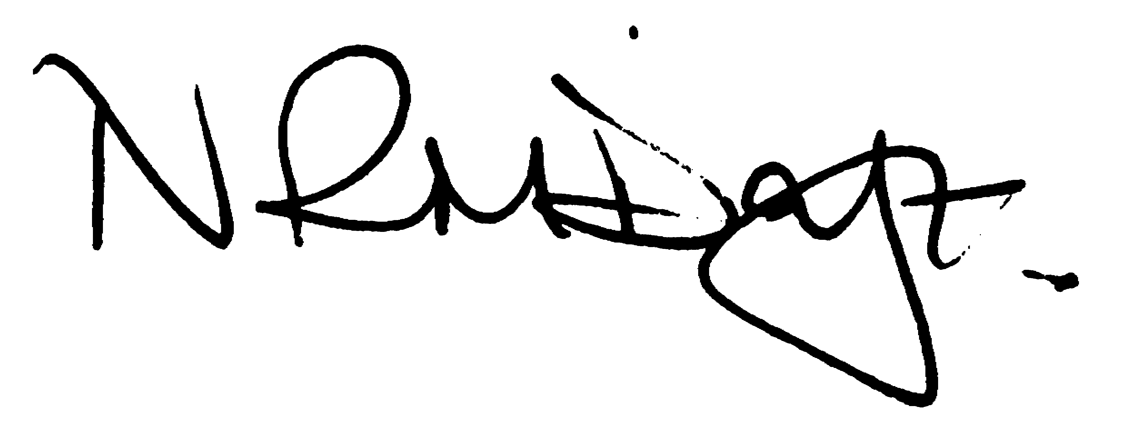

Nikki Daft – Parish Clerk

AGENDA

APOLOGIES AND ACCEPTANCE OF APOLOGIES

22/32 PUBLIC QUESTIONS, POLICE REPORT AND NNC UPDATE

Public to send questions to council prior to the meeting due to time constraints

22/33 NOTIFICATION OF ANY DISCLOSABLE PECUNIARY INTERESTS OR OTHER INTERESTS
Only in respect of matters which are to be considered by members below. (Disclosures previously declared and registered need not be repeated).

- To receive declarations of interest
- Councillors to declare any personal interest in any items on the agenda
- Councillors to declare any personal and/or prejudicial interest in any items on the agenda and to inform the Chairman if they wish to speak on the matter during public participation

22/34 MINUTES

a) To approve the minutes of the meetings held on 29th June 2022 and 26th July as true records.

22/35 FINANCIAL/POLICIES

- To Approve Payments for July and August 2022 (Clerk)
- To receive information regarding the current financial statement (Clerk)
- To agree the authorisation of the bacs payments
- To receive the details from the external auditor
- To receive information to opt out of the SAAA Central external Auditor Appointment Arangements

22/36 CEMETERY/WAR MEMORIAL

- To receive an update on cemetery matters

22/37 HIGHWAYS

- To receive an update on Highways matters

22/38 PLAY AREAS

- To receive an update regarding the play areas
- To receive the quotation from Wicksteed regarding the repairing of the wetpore on the Recreation Ground
- To discuss the issue with vegetation in Denton Close

22/39 COMMUNITY
- To receive a report from the community orchard
- To receive a request from the Bowls Club to renew the car parking lines in the shared car park
- To receive an update on the Library
- To discuss the organising of the Remembrance Day Service

22/40 PLANNING

- NW/22/00553/VAR Proposal: Variation of condition 20 of outline planning permission reference WP/19/00154/OUT as the approved plans include two first floor flats with ground floor access, by the nature of this type of dwelling they are not M4(2) Compliant and therefore for the development to be built in accordance with the approved drawings the wording of the condition needs to be amended. Proposed New Condition Wording: Condition 20: As part of any reserved matters submission all dwellings (excluding plots 15-16 as shown on approved drawing 18870/1006C1, and labelled as flats 2-3 on approved drawing RDC1159/151) would meet the requirements of the national Accessibility Standards in category 2 (accessible and adaptable dwellings) (70 dwellings in total) and 3No. dwellings would meet the requirements of Category 3 (wheelchair use) in accordance with the schedule of the Approved Document M of the Building Regulations (2015). The development shall be carried out in accordance with approved drawing 18870/1006C1. Location: Land Adjacent 79-81 Farndish Road And Rear 2 To 26 James Street
- NW/22/00530/FUL Single Storey side extension – 15-17 Station Road
- NW/22/00460/PAMB – Irchester Grange Farm – change of use of agricultural barn to single storey dwelling house Class C3

22/41 EXCLUSIVE TO PUBLIC AND PRESS

22/42 FUTURE IMPROVEMENTS TO IRCHESTER CEMETERY

To discuss future improvements to the cemetery

22/43 VILLAGE VOICE

To discuss and adopt the policy for the Village Voice

