IRCHESTER PARISH COUNCIL

Minutes of the Ordinary Meeting of the Parish Council held on Wednesday 26th April 2023 at the Village Hall, School Road at 7.15p.m.

Members Present:
P Armstrong– In the Chair

Councillors
P Smith L Brown JP Carr T Maguire S Bridge K Watts
C Ashford D Shroll K Clark V Blake S East

The meeting started at 7.15pm. There were 6 members of the public present.

Apologies - Agreed and Accepted from Cllrs J Dunkley S Vassell & M May

22/113 Public Questions, Police Report and NNC Update

Public: Concern was raised regarding the speeding traffic along Wollaston Road and Gypsy Lane. MOPs were informed of the progress so far in order to alleviate some issues.
An accident had occurred along Wollaston Road that damaged a wall and an electric pole. As no one was injured the police did not attend.

Police Report – No report received

NNC Report – Meeting regarding cycleway held at Swanspool was attended regards networking links to Irchester Country Park and Rushden were mentioned. Suggestion also of crossing point over A45. Several consultation taking place ie Energy Park and Short break for disabled children. Other details were in the Leaders report previously sent to councillors.

22/114 Notification of Any Interests

None declared

22/115 Minutes

The minutes from 29th March 2023 meeting were agreed as a true record and signed by the Chair.

22/116 Financial Matters

- Payments – Resolved: That the payments for £13,065.50 for April 2023 were approved.
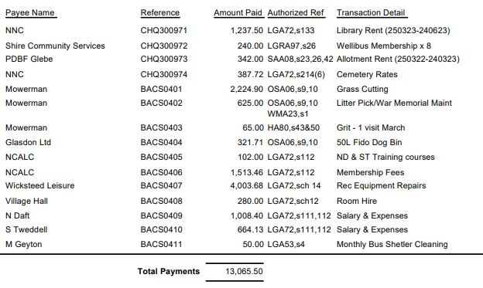

- The Current financial statement after the payments being £141,076.24
- RESOLVED that Cllrs P Smith and L Brown to authorise the bacs payments for April 2023
- The yearend reports reports to be sent to councillors
- The report from the Internal Auditor was received with comments noted
- Resolved to accept Section 1 of the 2022/23 AGAR with all boxes ticked
- Resolved to accept Section 2 of the 2022/23 AGAR

22/117 Cemetery/War Memorial

- Discussion took place regarding the water trough and it was agreed to replace the taps with push tops. This work to be completed under delegated powers if with the price range.
- A request had been received to have a 12” x 12” tablet in the middle of 2 cremated remains plots. It was agreed that a 3foot plinth would need to be on the base in order to align both the plots so as not too look out of line.

22/118 Highways

- A grant form for new VAS signs had been submitted to the Police Commissioners Office.
- There had been issues with Cadent regarding the replacement of the grass verges of which NNC would ask them to rectify.
- The MP had written to the Post Office regarding the post box request and may forward the petition to the House of Commons for a response from the Department for Business and Trade. Awaiting the outcome.

22/119 Play Areas
- The Fido Dog Bin on the recreation ground had been ordered. Repairs in the recreation ground had been completed.

22/120 Community Projects

- Orchard –.trees in blossom. New planters were being made which need to be filled with top soil ready for planting. It was resolved that up to £450 could be allocated towards the cost of the top soil. Six nesting boxes were being donated for the area and it was suggested to contact the school in order to get the children involved with the orchard
- Library –.Spring event had taken place selling books, dvds, cakes and tombola etc. Library to open on Wednesday afternoons with several events taking place. A book club will commence on Thursdays. Between January and March there had been 763 visitors. Rhyme time attendees being appox 26 per week.
- Bench – discussion took place regarding replacing the bench opposite the War Memorial. It was RESOLVED to purchase the butterfly bench and, if possible add a plaque to the bench to commemorate the Kings Coronation. Mulberry Homes had donated £200 towards the bench and asked for a quote from the pc. It was decided to say ‘Irchester Parish Council would like to thank Mulberry Homes for making a donation of £200 towards the new bench’.

22/121 Planning

- NW/23/00201/FUL Proposed new driveway and dropped kerb from Wollaston Road to serve existing property. Location: 132 Wollaston Road Irchester Wellingborough NN29 7DH – No comments raised

22/122 Correspondence

A request had been received from Taylors Amusement to have a fair on the Recreation Ground arriving on 18th June and opening 22nd to 24th June. It was agreed for them to attend at a cost of £250 plus £200 deposit as long as the risk assessments and insurance were all in order.

22/123 Exclusive to Public and Press

RESOLVED: That pursuant to the Public Bodies (Admission to Meetings) Act 1960, the public and press is excluded from the meeting for the item of business on the grounds that publicity would be prejudicial to the public interest by reason of the confidential nature of the business to be discussed.

22/124 Promotion Agreement

Details regarding the proposed Promotion Agreement were sent to the new solicitor who had advised that the land be valued and that certain restrictions be added to the agreement.

Meeting closed at 8.55 pm

Chair

