Any person employed to erect or fix any memorial must work under the direction of the Council and to the NAMM code of practice under the current British Standard.
For grounds maintenance and health and safety reasons, the placing of fencing, enclosures, kerb surrounds, border stones, chipping stones or pebbles is not permitted on any grave space. Some memorabilia may be placed on the grave space for grieving purposes but must be removed within a 12 month period to comply with these rules and regulations.
A programme of memorial testing is carried out to ensure that memorials are fixed safely within the cemetery. Where memorials are found to be loose or otherwise defective the Lessees will be, advised and given notice to make the memorial safe.(see General) In the event of a memorial posing an immediate threat to users of the cemetery or where Lessees having been advised that their memorial was unsafe and having not made good, immediate action will be taken to make it safe. This may result in the memorial being laid down or removed.
The Council may remove any memorial, or inscriptions thereon, placed in the cemetery without authorisation and recover any costs so incurred.
The Council will not be responsible for any accidents or damage to any memorial caused by vandalism, storm, wind, lighting, subsidence, general grounds maintenance or any cause that is beyond the Councils control. Owners of memorials are advised to take out appropriate insurance cover against theft or damage.
GENERAL
Change of address - We request that you notify the Council of any change of address as soon as possible so that the appropriate records can be updated.
Any person or persons who knowingly or wilfully contravene the Cemetery Rules and Regulations maybe the subject of criminal prosecution (Local Authorities' Cemeteries Order 1977 (Section 19).
Difference or Disputes - Should any difference or dispute arise as to the real intent, meaning or interpretation of these Rules and Regulations, the decision of an Authorised Officer and Representative of the Burial Authority shall be final.
The above rules and regulations are not exhaustive and where matters arise that are not specifically covered the Council with make such decisions as they consider to be reasonable and necessary for the day to day management and control of the Cemetery.
Alterations to regulations – The Council reserve the right to alter these regulations from time to time as they see fit.

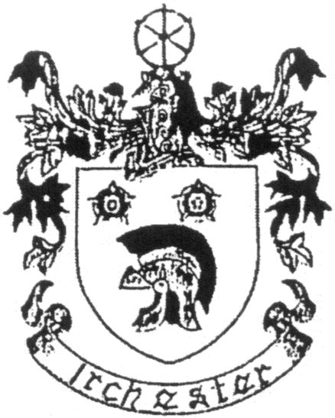

IRCHESTER PARISH COUNCIL
LESSEE
RULES AND REGULATIONS
JANUARY 2021

Contact Details: Parish Clerk 07525909528 or irchesterpc@gmail.com

RULES AND REGULATIONS FOR THE CONTROL AND MANAGEMENT OF
IRCHESTER CEMETERY, ST KATHARINES WAY, IRCHESTER, NORTHANTS
January 2021
These rules and regulations for the control and proper management of the Cemetery are made under the provisions of the Local Authorities Cemeteries Order 1977 and replace all previous rules and regulations made before June 2020

CONDUCT
The Local Authorities Cemeteries Order 1977 provides that "No person shall:
a. Wilfully create any disturbance in a cemetery.
b. Commit any nuisance in a cemetery.
c. Wilfully interfere with any burial taking place in a cemetery.
d. Wilfully interfere with any grave, tombstone or other memorial, or any flowers or plants.

The Irchester Parish Council state:

- No person is to enter or leave the cemetery other than through the main entrance.
- No vehicles may enter or leave the cemetery without specific permission from the Council
- Cycling in the cemetery is not allowed
- Other than at interments no music is to be played in the cemetery except with the specific agreement of the Council
- Dogs are only allowed in the cemetery whilst visiting as long as they are kept on a lead. Any mess should be removed immediately
- Children under 14 should be accompanied by a responsible adult.
- Any damage in the cemetery is to be made good at the expense of the person causing it.
- The Council reserves the right to exclude from the cemetery at any time all or any persons who are not members of the family of a deceased person whose funeral is taking place in the cemetery, or any persons not having any connection with such funeral.

EXCLUSIVE RIGHT OF BURIAL
No interment can take place in any grave unless a grant of exclusive right to burial has been granted by the Council. The name and address of the owner of this right, known as the Lessee, must be given to the Council at the time of giving notice of the interment.
Grants of exclusive right of burial are granted for a period of 50 years . At the expiry of a fixed period for which such a right has been granted, the Council may offer the Lessee an opportunity to purchase a further number of years. The Council may serve notice of determination on those graves where the grave does not appear to be tended and where the right has not been exercised for 5/10 years. The right will then cease unless the Lessee notifies the Council in writing of his/her wish to retain it for a further period.
Reopening of a grave space - Before a grave, in respect of which exclusive right of burial has been granted, can be re-opened to admit a further interment of ashes, the Council must be reasonably satisfied that the Lessee agrees to the interment. Normally the signature of the Lessee on the notice of interment will suffice providing the particulars appear to agree with records. If the deceased to be interred is the Lessee then normally the right would be transferred through the will or executor.
Any right granted may be transferred by deed by a Lessee to another person but the transfer must be agreed and recorded by the Council. Such right may also be bequeathed by will whose executors must confirm it’s accuracy in writing. In either case a transfer fee may be payable.

GRAVE MAINTENANCE
All grave spaces and memorials are to be kept in good repair by the Lessees.
No surrounds, palisading, soft toys, glass vases, jars or tins may be placed on grave spaces. Balloons, wind chimes or lights will not be allowed (except on the children’s area) Encroachment onto pathways and adjacent plots is not permitted.
Spoil/earth – The spoil/earth contained on a grave after a burial will be removed by the Contractors of The Council between 6 and 12 months after the burial has taken place in order to allow the ground to settle. The ground will then be levelled and reseeded.
Small shrubs, plants or flowers may be placed on any grave, except lawn graves, subject to approval by the Council & should not exceed three foot high or the length or width of the grave. Overgrown shrubs, plants or flowers may be removed by Council staff if appropriate. Anyone undertaking the maintenance of graves must make their own arrangements to remove any excess soil or stones from the cemetery.
Artificial shrubs, plants or flowers may be placed on graves but will be removed by cemetery staff when faded or appearing unsightly.
Dead flowers, waste paper and other refuse is to be put in the appropriate bins provided for that use and not left for disposal elsewhere in the cemetery grounds. The content of the bins are monitored by Wellingborough Council and misuse of the bins could result in them not being emptied.
On payment of the appropriate fees Lessees and interested parties may apply to the Council for the planting out and weeding of graves twice a year. (see fees)
Cemetery staff will remove floral tributes, when wilted or decayed. Christmas and other festive season tributes (wreaths etc.) will be removed within 3 months after the festival.

MEMORIALS
A memorial cannot be placed on a grave space until the ground has been levelled by The Council.

Lessees wishing to erect a memorial should contact a stonemason (who should be listed on the British Register of Accredited Memorial Masons (BRAMM) or National Association of Memorial Masons (NAMM) who must complete an application for a permit to undertake monumental work.

Approval of the permit by the Council is to be taken as conferring to the Lessee a grant of a right to place and maintain a memorial on the respective grave. Such right will expire on the same date as that of the exclusive right of burial.

If a grant of exclusive right of burial in a grave expires and is not extended, the Council may serve notice on the Lessee to remove any memorial from that grave and will display appropriate notices of intent in a locally and in the cemetery grounds. If after three months the memorial has not been removed, the Council may then remove and deal with it as it sees fit.

