IRCHESTER PARISH COUNCIL

Minutes of the Ordinary Meeting of the Parish Council held on Wednesday 27th November 2024 at the Village Hall, School Road at 7.15p.m.

Members Present:
K Watts – In the Chair

Councillors
P Armstrong A Hurley J-P Carr A Howden S East P Smith D Schroll M May G Brotherston

The meeting started at 7.15pm. There were 6 members of the public present. The Tim Maguire Trophy Cup was presented to the Chair of the Irchester Sports Association for the Christmas Skittles Competition

Chair thanked councillors for their help and support in organising the Remembrance Day Service.

The Chair also reiterated that items exclusive to public and press should be kept confidential to councillors only.

Apologies - received and accepted from Cllrs B Leeson, I MacDonald & J Dunkley

24/63 Notification of Any Interests

None declared

24/64 Public Questions, Police Report and NNC Update

Public – Query why high turn over of councillors and staff
Request to know when dog bins emptied
Request to have alternative speed enforcement other than the speed van

Police – No report had been received

NNC Update – Leaders report sent to councillors. NNC Cllr T Partridge Underwood mentioned that Chester House had been on the local news.
He stated that the police and fire services had been really helpful to everyone during the local flooding and the consultation regarding the Greenhill solar farmwas still ongoing.

24/65 Minutes

RESOLVED - The minutes from 30th October 2024 meeting was agreed as a true record and signed by the Chair.

24/66 Financial Matters

- Payments – To agree the payment for October and November 2024 as listed below.
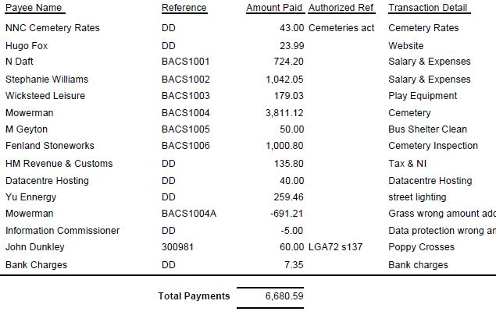

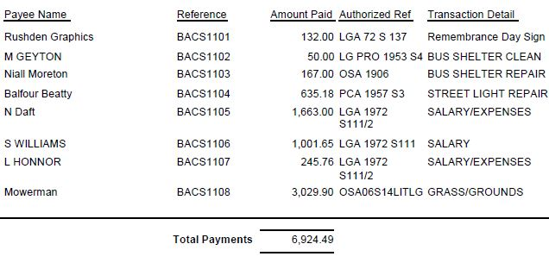

- The Current financial statement after the payments £221,884.04, but not including the DD’s
- RESOLVED that Cllrs JP Carr & P Armstrong to authorise the bacs payments for November 2024.
- RESOLVED to agree the Budget for 2025/26 as £173,180
- RESOLVED to agree the Precept for 2025/26 as £107,386

24/67 Recreation Grounds

- No issues raised although the annual inspection is still pending

24/68 Highways
Suspend standing orders for NNC Cllr TPU to speak
- Resident has issue with NNC trees who has already been advised that they need to deal directly with the NNC insurers as the parish council cannot get involved.
SO resumed
- Notice boards – RESOLVED to purchase 2 notice boards for £682 plus fitting
- Defibrillator batteries – RESOLVED to purchase 2 batteries for £234 plus fitting

24/69 Cemetery/War Memorial

Complaints had been received regarding an overgrown plot of which the Lessee has been contacted and agreed to tidy the area.

The memorial testing had been carried out and letters were being sent to lessees where headstones had failed.

Flag poles – RESOLVED to have the 3 flag poles maintained at a cost of £345 plus VAT

24/70 Correspondence

- Letter had been received regarding the consultation for the Green Hill Solar Farm
- Letter had been received regarding the land for sale in Farndish
- Tree Survey – RESOLVED to remove the dead tree on the Recreation as soon as possible. Further work needs to be carried out within the next 2 years.

24/71 Exclusive to Public and Press

RESOLVED: That pursuant to the Public Bodies (Admission to Meetings) Act 1960, the public and press is excluded from the meeting for the item of business on the grounds that publicity would be prejudicial to the public interest by reason of the confidential nature of the business to be discussed.

24/72 Sports Association(SA) Lease

Details regarding the SA lease were taken to the Councils solicitor however in the meantime they would like to apply for a grant to replace the tractor and would like the Council to go into partnership with them. It was agreed to contact the solicitor and ask them to send a letter stating that the lease would be renewed which would be over a ten year period as the lease required.

Meeting closed at 8.35pm

Chair

These minutes are draft until agreed at the next full council meeting

