IRCHESTER PARISH COUNCIL

Minutes of the Ordinary Meeting of the Parish Council held on Wednesday 25th October 2023 at the Village Hall, School Road at 7.15p.m.

Members Present:
K Watts – In the Chair

Councillors
L Brown JP Carr A Hurley B Leeson S East D Shroll K Clark P Smith

The meeting started at 7.15pm. There were 1 member of the public present and PCSO D Fenner.

One minutes silence was held for the late T Perkins who was an ex councillor of the parish.

Apologies - Received by the Clerk which were Agreed and Accepted from Cllrs J Dunkley, P Armstrong, M May Claire Ashford. S Bridge & T Maguire

23/48 Public Questions, Police Report and NNC Update

Public: Concern was raised regarding the access to the solar farm site from Gipsy Lane. It was stated that this is an access that the construction traffic can use to enter the site. Once the site is complete it will be for maintenance access only. There are no signs from the company informing road users of construction traffic

Police: Crime stats for September were given to the councillors at the meeting from PCSO Fenner. The police now have a specific parking team dealing with parking issues. PCSO left the meeting

NNC report – Apologies from T Partridge-Underwood. Leaders update previously sent to councillors nothing further to add.

23/49 Notification of Any Interests

Cllr Leeson 23/55 b. The Chair asked Cllr Leeson to remain in the room during this agenda item

23/50 Minutes

The minutes from 27th September 2023 meeting were agreed as a true record and signed by the Chair.

23/51 Financial Matters

- Payments – Resolved: That the payments for £9165.41 October 2023 were approved. Direct Debits for October being N Power, HMRC & Hugh fox website
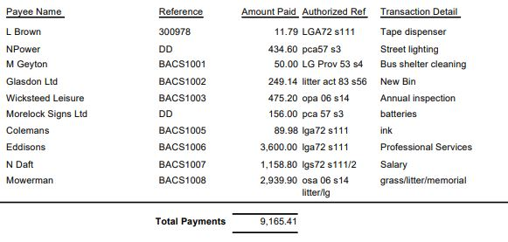

- The Current financial statement after the payments being £225,345.57
- RESOLVED that Cllrs JP Carr & L Brown to authorise the bacs payments for October 2023

23/52 Cemetery/War Memorial

- It was stated that several interments had taken place throughout September but so far October was quiet.

23/53 Highways

- No new issues to be reported
- VAS stats from the 4 signs were sent to councillors. RESOLVED to purchase a new set of batteries for the new signs
- There was no further update from Highways regarding the alleyways.

23/54 Play Areas

- The repairs from the annual inspection had been ordered for the Wicksteed equipment. HAGS had been contacted regarding the skate park and a report is pending.

23/55 Community

- Discussion took place regarding the Remembrance Day Service and it was agreed that the format would stay the same as in previous years with the Reachout Church leading the service. There was a query regarding the display using black poppies and it was agreed these should be included. Little Irchester service to use the same format as in previous years.
- Discussion took place regarding the proposed meeting with the YCT committee as they were unhappy regarding who would chair the meeting. Unfortunately there was a misunderstanding regarding the reason for the meeting as the YCT committee believed they were being ‘investigated’ by the pc rather than it being an informal meeting. Confirmation of this to be sent to the committee.

23/56 Planning

- NW/23/00632/FUL – Single storey extension – 33 Knuston Spinney Irchester – No comment
- NW/23/00649/FUL – Erection of double garage – 68 High Street Irchester – No comment

23/57 Correspondence

- Information was received from MP P Bone stating that he would once again write to the Royal Mail regarding the post box for the centre of the village as advised by the house
- Details regarding the anti social behaviour on the recreation ground was emailed to the office of the PCC who needed the authorisation from the recipient before progressing. No further details have been received.
- Greenway – This was a two part conservation regarding the routes and also regarding the river which would link Peterborough to Wellingborough. Concern was raised regarding not having future provision for the area ie the bridge as stated in the Irchester NHP, the footpath over the New Bridge to Ditchford Lane crossing points and the lack of disable access on the accessible routes. It was stated that a meeting was to be held next week which may explain things further.

23/58 Exclusive to Public and Press

RESOLVED: That pursuant to the Public Bodies (Admission to Meetings) Act 1960, the public and press is excluded from the meeting for the item of business on the grounds that publicity would be prejudicial to the public interest by reason of the confidential nature of the business to be discussed.

23/59 Promotion Agreement Austin Close

The recommendations from Addisons for the promotion agreement were sent to the promoters agent however a response has not yet been received. The soft market research has been carried out of which it is advised to include within the promotion agreement.

Meeting closed at 8.23 pm

Chair

These minutes are draft until agreed at the next full council meeting

