
The Parish Council of Irchester
Clerk  Nikki Daft PSLCC  45 Park Road  Irthlingborough  Northants  NN9 5PW |  | Telephone 07525 909528  irchesterpc@gmail.com

Dear Councillor 20th January 2020

You are hereby summoned to attend the Ordinary meeting of Irchester Parish Council to be held in the Village Hall, School Road Irchester on Wednesday 29th January 2020 at 7.15p.m.

Yours faithfully
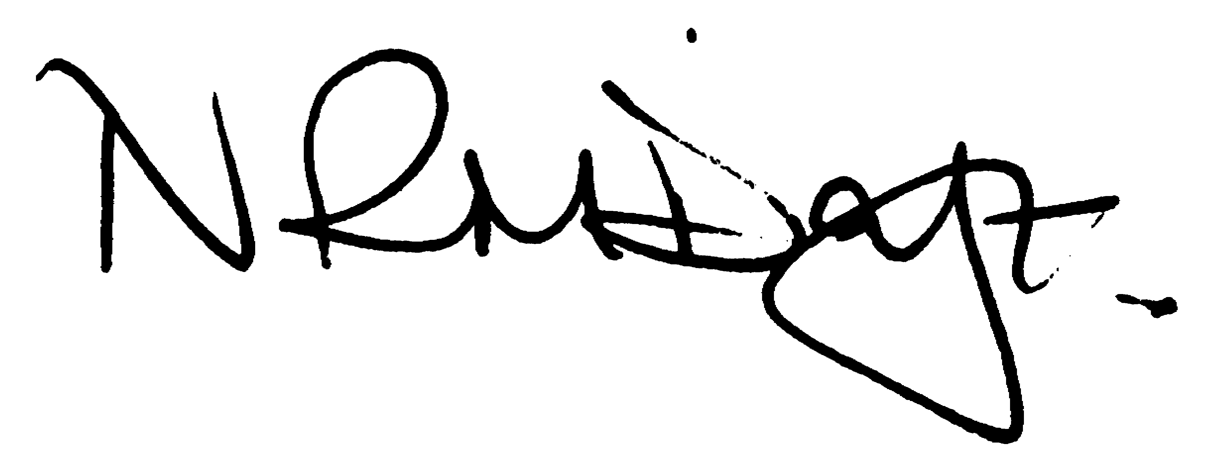

Nikki Daft – Parish Clerk

AGENDA

APOLOGIES AND ACCEPTANCE OF APOLOGIES

19/83 PUBLIC QUESTIONS AND/COMMENTS

Public participation may continue until for 15 minutes after which the public must not take part at any other time during the meeting. Any member of the public can make a recording of any part of the meeting. All audible sounds to be switched to silent unless otherwise agreed at the start of the meeting.

POLICE REPORT AND NCC UPDATE

To receive a verbal report from the Police and NCC representative if in attendance

19/84 NOTIFICATION OF ANY DISCLOSABLE PECUNIARY INTERESTS OR OTHER INTERESTS
Only in respect of matters which are to be considered by members below. (Disclosures previously declared and registered need not be repeated).

- To receive declarations of interest
- Councillors to declare any personal interest in any items on the agenda
- Councillors to declare any personal and/or prejudicial interest in any items on the agenda and to inform the Chairman if they wish to speak on the matter during public participation

19/85 MINUTES - To approve the minutes of the meetings held on 27th November 2019 as a true record.

19/86 RESOLUTIONS AND ACTIONS - MATTERS FROM PREVIOUS MINUTES

- Light Arkwright Road – monitor angle
- Solicitor – confirm agreement of lease
- Post box – write regarding post boxes in other areas
- Playground repairs – order
- BCW confirm precept increase
- Highways – confirm agreement of Station Road loading bay changes

19/87 FINANCIAL/POLICIES

- To Approve Payments for January 2020 details sent to councillors via email (Clerk)
- To receive information regarding the current financial statement – reconciliation statement sent to councillors via email (Clerk)
- To agree the authorisation of the bacs payments

19/88 RECREATION GROUNDS

- To receive and agree the reports/repairs/damage to the recreation grounds (JD)

19/89 HIGHWAYS

- To agree any items that need to be added to the next agenda
- To agree the Urban Highway Grass Mowing agreement with NCC for 2020 in order to receive a grant of £2130.95 for cutting the grass verges

19/90 LITTLE IRCHESTER/KNUSTON - To agree the Highway Warden report. Matters arising will be added to the next agenda.

19/91 CEMETERY/WAR MEMORIAL/GARDENS

To receive an update regarding cemetery matters

19/92 PLANNING

WP/20/00015?FUL – Single storey side extension 12 School Hill
WP/20/00027/FUL – Reuse existing building for Thai Buddhist meditation centre – Knuston Vale, Station Road

19/93 CORRESPONDENCE To consider information received from incoming correspondence and decide on agenda items for the next meeting.

- Request from James Richards Circus to use recreation ground from Friday 23rd October to Sunday 25th October 2020
- Thank you letter received from Village Hall Trust Committee
- Letter from police regarding a ANPR scheme at a cost of £3500-£4000 for a camera and between £30-£50 monthly cost for servicing, electricity and data transfer

