IRCHESTER PARISH COUNCIL

Minutes of the Ordinary Meeting of the Parish Council held on Wednesday 28th November 2018 at Village Hall, School Road, Irchester at 7.15p.m.

Members Present:
K Watts – In the Chair

Councillors
JP Carr P Smith Mr D May C Elliott R Elliott
P Armstrong M May T Maguire D Shroll L Ellis Day J Gibson J Dunkley A May

The meeting started at 7.15pm. There were 3 members of the public present

Apologies - Cllr L Brown. & NCC M Griffiths

Absent Councillors: None

The Chair asked if item 18/79 e) could be moved to Exclusive to Public and Press after discussion had taken place regarding the library. It was resolved to move this item to Exclusive to Public and Press. The Chair also reminded Councillors of Standing Orders regarding the rules of debate.

18/75 Public participation

Concern was raised regarding horses being allowed to train on the Wollaston Road recreation ground, the damage they were causing to the grass and who would be responsible should an accident occur. Public were informed that the police were aware and the item would be discussed during the meeting.

Police Report – This was circulated to councillors and updated during meeting noting that several sheds had been broken into.

JAG meeting – the Chair has attended the last JAG meeting where fly tipping was a concern. It was noted that an individual had been prosecuted even though they had employed someone to remove the waste that had been tipped. It was also noted that a cyclist had been seen monitoring properties when empty.

The police were due to attend the next PC meeting in January 2019 and councillors were asked to submit any questions to the Clerk relating to policing issues that could be forwarded to them in preparation of the meeting.

It was agreed that a letter be sent to the Home Secretary regarding the lack of police presence in the rural areas as officers had been reduced from 9 to 4 and the lack of funding available.

18/76 DPI's

DPI’s – None recorded

18/77 Minutes

The minutes from 31st October 2018 were agreed as a true record

18/78 Actions/Matters from previous minutes

Planning responses – completed Solar light – installed Letter to Players - sent
Police – letter sent Grit bin licence – sent Rota – completed
Damaged seat – sorted Quotations – requested Tree trimming - ordered

Query was raised regarding the brightness of the new solar light however it was noted that the weather had been extremely dull over the past few weeks. The light to be monitored.

18/79 Financial Matters

- Approval of Payments – Resolved: That the payments of £9075.67 for November 2018 be approved.

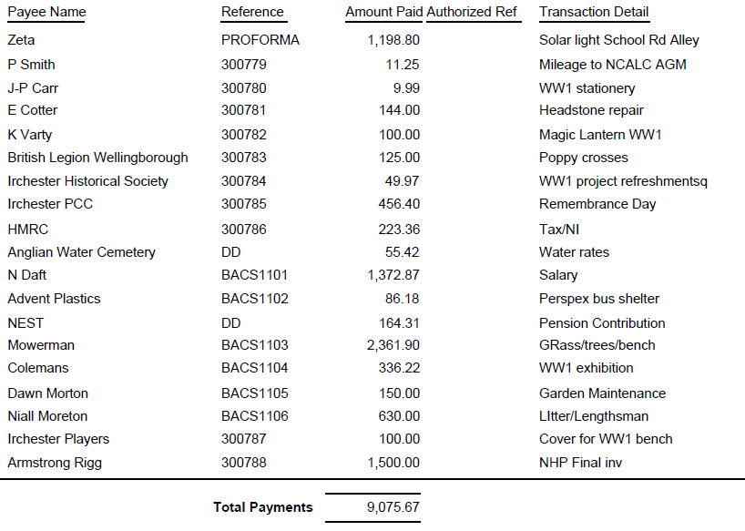

- Current financial statement – sent to councillors prior to the meeting.
- RESOLVED that Cllr P Armstrong and JP Carr authorise the bacs payments for November
- RESOLVED to purchase the 11th Edition of Council Administration for the Clerk
- No comments were raised regarding the Staffing Working Party Notes

18/80 Recreation Grounds

- The annual inspection of the play areas had been carried out however the report has not yet been received.
- Discussion took place regarding the horses using the recreation ground to exercise and it was agreed to write to Mr Doughty regarding the councils concerns and to look at creating a byelaw for the future. Reference was also made to installing a fence of which councillors were reminded that this was covered in the NHP wish list.

18/81 Highways –

- It was stated that highways had carried out some pot hole repairs and marked others
- Gritting – it was agreed that the gritting of the designated footpath areas be carried out in conjunction with NCC gritting programme and that councillors would notify the Clerk regarding severe weather conditions in the village.

18/82 Little Irchester/Knuston

The vegetation from the bushes overhanging the footpath had been cut back.

18/83 Planning

- WP/18/00675/FUL - Proposal: Proposed 2 bedroom detached bungalow adjacent to 2 Wollaston Road, - Irchester - re-submission 2 Wollaston Road, Irchester, Wellingborough, Northamptonshire, NN29 7DE – no comments raised
- Application No. WP/18/00698/FUL Proposal: Erection of single storey side extension Location: 14 School Hill, Irchester, Wellingborough, Northamptonshire, NN29 7AN -
- Application No. WP/18/00688/FUL – the Council stated they had reservations regarding the character and design and would like the views from the Conservation Officer regarding the application
Proposal: Erection of 1no. bungalow with associated garden area and parking Location: Land To The Rear Of, 31 Edward Road, Irchester, Wellingborough, Northamptonshire, NN29 7BN – the Council have requested a site viewing on this application regarding the size and appearance and the view regarding the grade 1 listed church as per the details in the Neighbourhood Plan.

18/84 Cemetery/War Memorial

- The Cemetery Working Party had met and a report was circulated to councillors. It was stated that the plants and the tree for the first circle had been completed and the yew hedge for the baby section had also been carried out. No further questions or comments were raised.

18/85 Community/Consultation Events

- The Village Voice Working Party had met and a report was circulated to councillors. No comments were raised regarding the notes.
- The next meeting of all the working parties was due to take place on 15th January 2019 in the Committee Room of the Village Hall and it was suggested that :
Village Voice WP meet between 6pm and 7pm
Cemetery WP plus the Clerk meet between 7pm and 8pm
Staffing WP plus the Clerk meet between 8pm and 9pm
- Unitary – it was agreed to ask Cllr M Griffiths from NCC if he could attend the parish council for an update in February 2019.

18/86 Correspondence

- Email from resident regarding CCTV – not to pursue at this time
- Email regarding the visit of the mobile Rural Information Centre in 2019. TM to speak to Working Men’s Club regarding the unit using the car park
- Invite to the Parish Forum on 4th December – attendees KW,RE & LED
- Poster from Royal Air Force for notice board

18/87 Exclusive to Public and Press

RESOLVED: That pursuant to the Public Bodies (Admission to Meetings) Act 1960, the public and press is excluded from the meeting for the item of business on the grounds that publicity would be prejudicial to the public interest by reason of the confidential nature of the business to be discussed.

18/88 Library

- Discussion took place regarding the offers sent from NCC regarding the library service. It was agreed to confirm the PC’s expression of interest in offer 1 however the rent being asked for the building was not acceptable. The building was in disrepair and if was felt that this needed addressing before any transfer took place.
- Discussion took place regarding instructing a consultant to carry out a Business Plan. It was agreed that the consultant should be engaged.
- Discussion took place regarding members of the Library working party and it was agreed that members of the Friends of the Library, organisations and representatives would be invited to the working party meeting as guests as and when it was felt applicable.

Precept – it was agreed to have a further budget meeting on Saturday 19th January 2019 at 10am to be held in the library.

There being no further business the meeting closed at 9.25 pm Chair

