
The Parish Council of Irchester
Clerk  Nikki Daft PSLCC  45 Park Road  Irthlingborough  Northants  NN9 5PW |  | Telephone 07525909528  irchesterpc@gmail.com  www.hugofox.com/community/irchester-parish-council-13388/about-us

Dear Councillor 19th April 2022

You are hereby summoned to attend the ordinary meeting of Irchester Parish on Wednesday 27th April 2022 at 7.15p.m.at the Village Hall, School Road, Irchester

Yours faithfully
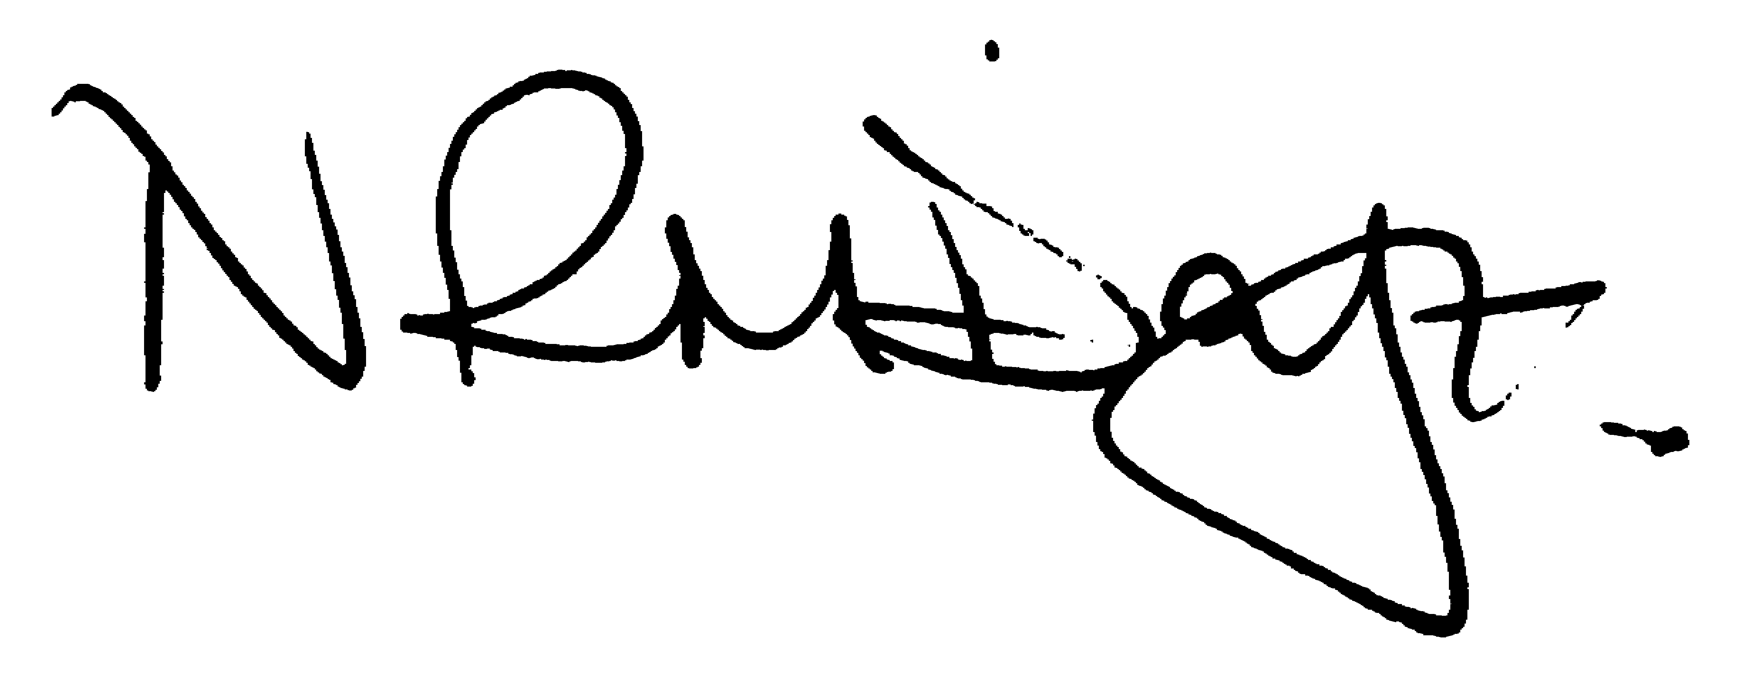

Nikki Daft – Parish Clerk

AGENDA

APOLOGIES AND ACCEPTANCE OF APOLOGIES

21/106 PUBLIC QUESTIONS, POLICE REPORT AND NNC UPDATE

Public to send questions to council prior to the meeting due to time constraints

21/107 NOTIFICATION OF ANY DISCLOSABLE PECUNIARY INTERESTS OR OTHER INTERESTS
Only in respect of matters which are to be considered by members below. (Disclosures previously declared and registered need not be repeated).

- To receive declarations of interest
- Councillors to declare any personal interest in any items on the agenda
- Councillors to declare any personal and/or prejudicial interest in any items on the agenda and to inform the Chairman if they wish to speak on the matter during public participation

21/108 MINUTES

a) To approve the minutes of the meeting held on 30th March 2022 as a true record.

21/109 FINANCIAL/POLICIES

- To Approve Payments for April 2022 (Clerk)
- To receive information regarding the current financial statement (Clerk)
- To agree the authorisation of the bacs payments
- To receive end of year accounts
- To receive the Internal Audit report
- To agree Section 1 of the AGAR
- To agree Section 2 of the AGAR

21/110 CEMETERY/WAR MEMORIAL

- To receive an update on cemetery matters

21/111 HIGHWAYS

- To receive an update on Highways matters

21/112 PLAY AREAS

- To receive an update regarding the play areas

21/113 COMMUNITY
- To receive an update on the community orchard.
- To receive an update on the Library
- To receive an update on the Queens Platinum Jubilee Celebrations and discuss request for expenses for the event
- To discuss the grant request from the Irchester Allotment Association

21/114 EXCLUSIVE TO PUBLIC AND PRESS

21/115 OLB

To discuss the recommendations and budget for OLB

