
The Parish Council of Irchester
Clerk  Nikki Daft MILCM  45 Park Road  Irthlingborough  Northants  NN9 5PW |  | Telephone 01933 384180  Parishclerk123@gmail.com

Dear Councillor 15th February 2016

You are hereby summoned to attend the Ordinary meeting of Irchester Parish Council to be held at Village Hall, Irchester on Wednesday 24th February 2016 at 7.15p.m.

Yours faithfully
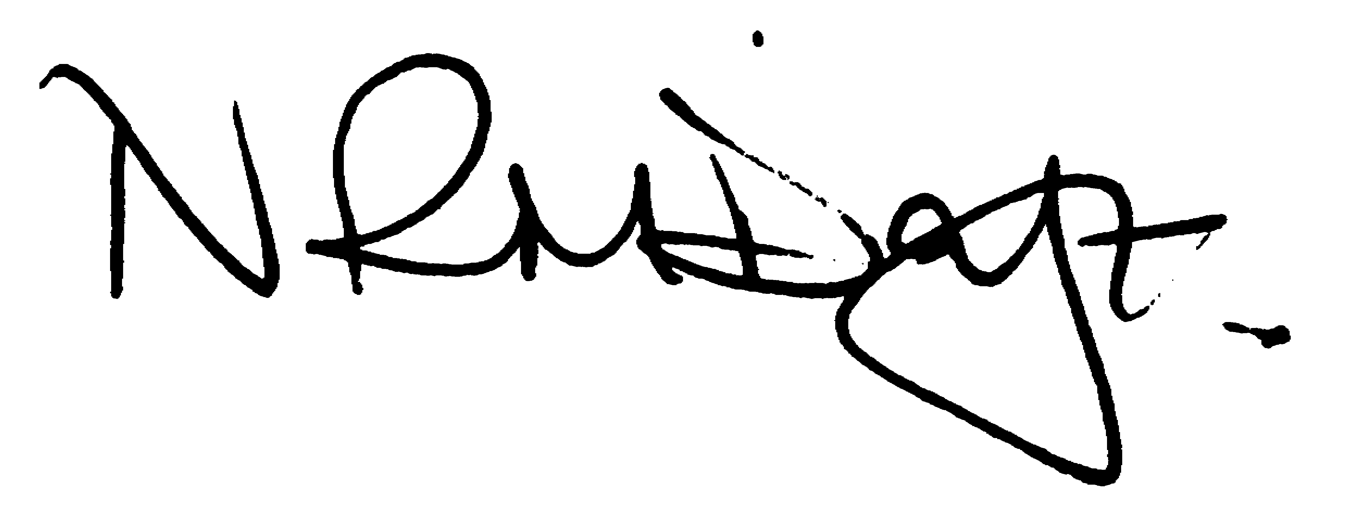

Nikki Daft – Parish Clerk

AGENDA

APOLOGIES AND ACCEPTANCE OF APOLOGIES

15/98 NOTIFICATION OF ANY DISCLOSABLE PECUNIARY INTERESTS OR OTHER INTERESTS
Only in respect of matters which are to be considered by members below. (Disclosures previously declared and registered need not be repeated).
• To receive written requests for dispensations for disclosable pecuniary interests (if any)
• To consider any requests for dispensations as appropriate

15/99 MINUTES

a) To approve the minutes of the meetings held on 27thJanuary 2016 as true records

15/100 PUBLIC QUESTIONS, POLICE REPORT AND NCC UPDATE

Public participation may continue until for 15 minutes after which the public must not take part at any other time during the meeting. Please note that the meeting maybe recorded. All audible sounds to be switched to silent unless otherwise agreed at the start of the meeting. A report only can also be given by the Police and NCC representatives

15/101 RESOLUTIONS AND ACTIONS - MATTERS FROM PREVIOUS MINUTES
Agenda | Task | By | Completed/comments
Jan | Recreation Weed killing | Clerk | Ordered
 | Yellow Lines form | Clerk | Completed
 | Bradshaw vegetation cut back | Clerk | Ordered
 | Poached areas in play grounds | Clerk | Ordered
 | Play equipment review | Rec Grp | To organise
 | Procurement procedures | Fin Grp | Meeting 2 March
 | Parking School Road/Lane | Cllrs | Monitor after works completed

15/102 FINANCIAL/POLICIES

- To Approve Payments for February 2016 (Clerk)
- To receive information regarding the current financial statement (Clerk)
- To agree the authorisation of the bacs payments
- To discuss the request for grant funding for the wetpore area for the ABC pre-school

15/103 RECREATION GROUNDS

- To receive and agree the reports/repairs/damage to the recreation grounds
- To receive quotations for adding grass matting to the seating areas near the Skate park in Austin Close.
- To discuss the possibility of placing grass matting at the corner of the Recreation ground leading to Alfred Street

15/104 HIGHWAYS

- To receive an update regarding the proposed yellows lines in the Arkwright Road area
- To receive information regarding litter in Arkwright Road and what course of action the pc may take
- To discuss the possibility of purchasing a Vehicle Activated Sign for the Station Road area due to the amount of accidents being reported.

15/105 LITTLE IRCHESTER/KNUSTON

- To agree the Highway Warden report. Matters arising will be added to the next agenda

15/106 PLANNING

To receive an update on planning matters

- Appeal re Outline planning application for Chester Road/High Street
- Appeal 203 Wollaston Road re demolition of bungalow and erection new dwelling amended plans
- Approval of reserved matters WP/16/0072/REM Land Adj 153 Bradshaw Way

15/107 NEIGHBOURHOOD PLAN

- To receive an update on the NH Plan

15/108 CEMETERY/WAR MEMORIAL

- Registrar report – matters for next agenda

15/109 COMMUNITY

- To discuss the production of the Village Voice ready for printing and who will complete the work
- To discuss the possibility of a defibrillator for the village, funding and housing
- To discuss contacting the school regarding litter and possibility of litter poster competition
- To discuss purchasing wireless multi microphone system for use at meetings in order for the councillors nad general public to hear all aspects of debates.
- To discuss the possibility of entering the Best Village Competition

15/110 AMENDMENT CONSULTATION TO THE NNJPU

To discuss the following amendments to the NNJPU -
- MM2 protection of farmland near to the SSI in Nene valley
- MM3 re strengthen priority to be given to development of brownfield sites. Developer pressed for this to be watered down at the enquiry. Key change
- MM11 good criteria for rural exceptions
- MM24 protection of heritage assets- strengthen phrase - Relates St Katherine’s Church

15/111 CORRESPONDENCE

To consider information received from incoming correspondence and decide on agenda items for the next meeting

.

