
The Parish Council of Irchester
Clerk  Nikki Daft  45 Park Road  Irthlingborough  Northants  NN9 5PW |  | Telephone 07525909528  irchesterpc@gmail.com  www.hugofox.com/community/irchester-parish-council-13388/about-us

Dear Councillor 16th October 2023

You are hereby summoned to attend the ordinary meeting of Irchester Parish on Wednesday 25th October 2023 at 7.15p.m.at the Village Hall, School Road, Irchester

Yours faithfully

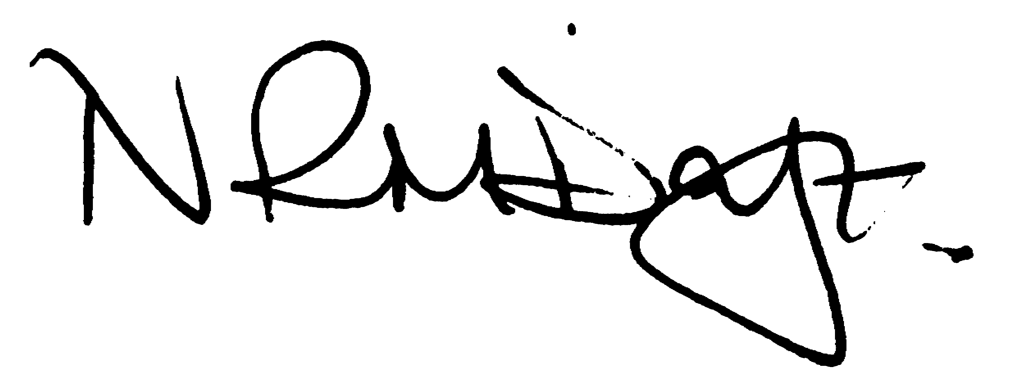

Nikki Daft – Parish Clerk

AGENDA

APOLOGIES AND ACCEPTANCE OF APOLOGIES

23/48 PUBLIC QUESTIONS, POLICE REPORT AND NNC UPDATE

Public are requested to send specific questions to council prior to the meeting due to time constraints

23/49 NOTIFICATION OF ANY DISCLOSABLE PECUNIARY INTERESTS OR OTHER INTERESTS
Only in respect of matters which are to be considered by members below. (Disclosures previously declared and registered need not be repeated).

- To receive declarations of interest
- Councillors to declare any personal interest in any items on the agenda
- Councillors to declare any personal and/or prejudicial interest in any items on the agenda and to inform the Chairman if they wish to speak on the matter during public participation

23/50 MINUTES

- To approve the minutes of the meeting held on 27th September 2023 as a true record.

23/51 FINANCIAL/POLICIES

- To Approve Payments for October(Clerk)
- To receive information regarding the current financial statement (Clerk)
- To agree the authorisation of the bacs payments

23/52 CEMETERY/WAR MEMORIAL

- To receive an update on cemetery matters

23/53 HIGHWAYS

- To receive an update on any Highways issues
- VAS signs report plus purchase a new set of batteries
- To receive an update from NNC Highways regarding the state of the alleyways

23/54 PLAY AREAS

- To receive an update of the play areas

23/55 COMMUNITY

- To discuss the progress of Remembrance Day Service for November 2023
- To discuss the proposed meeting with the YCT Committee

23/56 PLANNING

- NW/23/00632/FUL – Single storey extension – 33 Knuston Spinney Irchester
- NW/23/00649/FUL – Erection of double garage – 68 High Street Irchester

23/57 CORRESPONDENCE

- To discuss and agree the Parish Council response to the North Northamptonshire Greenway Strategy & North Northamptonshire Greenway Strategy – Wellingborough to Rushden route Consultations

23/58 EXCLUSIVE TO PUBLIC AND PRESS

To agree to discuss the following item exclusive to public and press

23/59 UPDATE ON AUSTIN CLOSE PROMOTION AGREEMENT

To discuss further information regarding the proposed promotion agreement

