
The Parish Council of Irchester
Clerk  Nikki Daft MILCM  45 Park Road  Irthlingborough  Northants  NN9 5PW |  | Telephone 01933 384180  Parishclerk123@gmail.com

Dear Councillor 16th November 2015

You are hereby summoned to attend the Ordinary meeting of Irchester Parish Council to be held at Village Hall, Irchester on Wednesday 25th November 2015 at 7.15p.m.

Yours faithfully
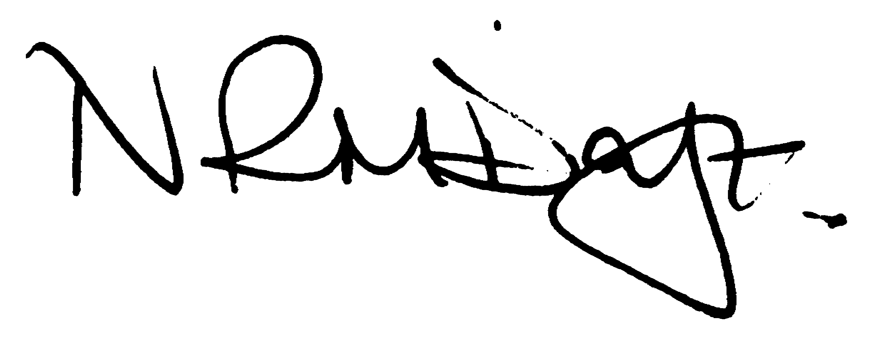

Nikki Daft – Parish Clerk

AGENDA

APOLOGIES AND ACCEPTANCE OF APOLOGIES

15/73 NOTIFICATION OF ANY DISCLOSABLE PECUNIARY INTERESTS OR OTHER INTERESTS
Only in respect of matters which are to be considered by members below. (Disclosures previously declared and registered need not be repeated).
• To receive written requests for dispensations for disclosable pecuniary interests (if any)
• To consider any requests for dispensations as appropriate

15/74 MINUTES

a) To approve the minutes of the meetings held on 28th October 2015 as true records

15/75 PUBLIC QUESTIONS, POLICE REPORT AND NCC UPDATE

Public participation may continue until for 15 minutes after which the public must not take part at any other time during the meeting. Please note that the meeting maybe recorded. All audible sounds to be switched to silent unless otherwise agreed at the start of the meeting. A report only can also be given by the Police and NCC representatives

15/76 RESOLUTIONS AND ACTIONS - MATTERS FROM PREVIOUS MINUTES

Agenda | Task | By | Completed/comments
Oct | Rec – quotes for repairs/removals | Clerk | Agenda item
 | Quotes for war memorial | Clerk | Agenda item
 | Parking School Road - police | Clerk | Agenda item
 | NCC highways visit | Clerk | Agenda item
 | Highways Agency A14/Chester Rd light | Clerk | Agenda item
 | Football litter on Saturdays | Clerk | Email sent
 | Alleyway Alfred St NCC cut back | Clerk | Confirmed
 | Steps clearing war memorial | Clerk | Email sent
 | Christmas flag | Clerk | Ordered

15/77 FINANCIAL/POLICIES

- To Approve Payments for November 2015 (Clerk)
- To receive information regarding the current financial statement (Clerk)
- To agree the authorisation of the bacs payments
- To agree the budget figures and set the precept for 2016/17

15/78 RECREATION GROUNDS

- To receive and agree the reports/repairs/damage to the recreation grounds
- To receive quotations for repair of various pieces of equipment
- To consider allowing Pindar circus to use the recreation ground between 21st to 23rd March and agree the cost

15/79 HIGHWAYS

Street Doctor updates :
752547 – Footpath from Railway bridge to Knuston – Repaired
752576 – Footpath Chester Road – Work instructed 1st September
755207 – Footpath condition Newtown Road – Work instructed will be completed by Jan 2016
755595 – Weed spraying of gutters – being undertaken
756146 – Branches of conifer tree overhanging path near Bowls club – responsibility of land owner

- To received information regarding the parking in School Road
- To received information regarding NCC response to parking in School Lane
- To received information regarding Highways Agency A14 street light
- To discuss the kissing gate for Townwell Lane

15/80 LITTLE IRCHESTER/KNUSTON

- To agree the Highway Warden report. Matters arising will be added to the next agenda

15/81 PLANNING

To receive an update on planning matters

- WP/15/00473/FUL – amended plans for demolition of bungalow and replace 203 Wollaston Road

15/82 NEIGHBOURHOOD PLAN

- To receive an update on the NH Plan

15/83 CEMETERY/WAR MEMORIAL

- Registrar report – previously circulated – matters for next agenda

IMPORTANT ITEM

- War Memorial – to discuss the quotations for the removing of the other spikes on the War Memorial fencing

15/84 ORGANISATION REPORTS/SUGGESTIONS

- To discuss and agree costs to include colour advertisements for the Village Voice

15/85 CORRESPONDENCE

To consider information received from incoming correspondence and decide on agenda items for the next meeting
.
- To make comment on the Wollaston NHP consultation

