
The Parish Council of Irchester
Clerk  Nikki Daft PSLCC  45 Park Road  Irthlingborough  Northants  NN9 5PW |  | Telephone 07525909528  irchesterpc@gmail.com  www.hugofox.com/community/irchester-parish-council-13388/about-us

Dear Councillor 15th November 2021

You are hereby summoned to attend the ordinary meeting of Irchester Parish on Wednesday 24th November 2021 at 7.15p.m.at the Village Hall, School Road, Irchester

Yours faithfully
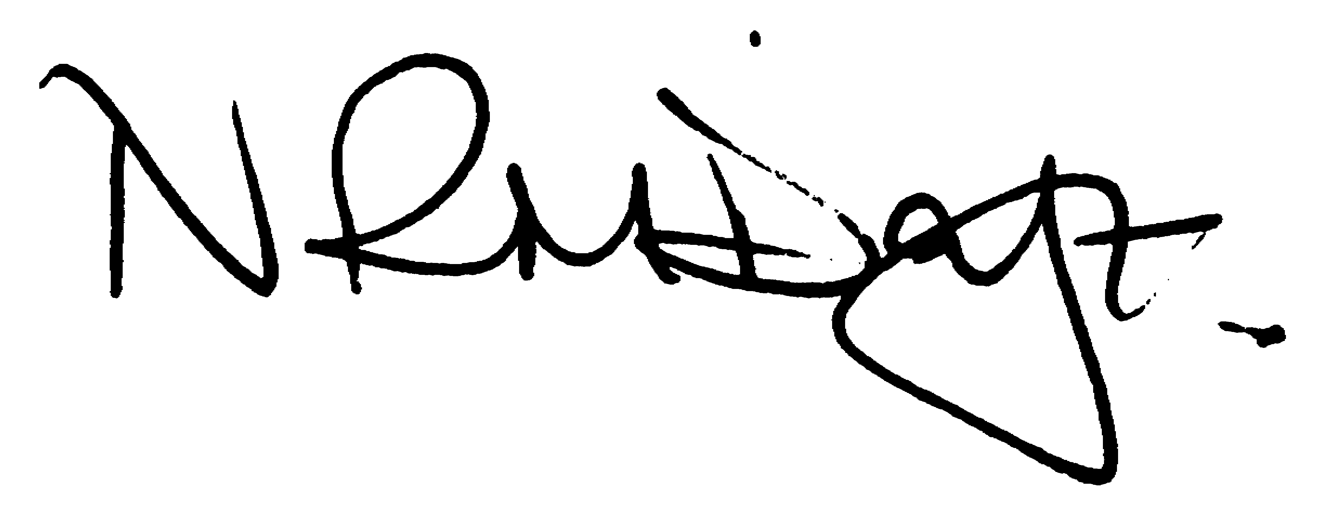

Nikki Daft – Parish Clerk

AGENDA

APOLOGIES AND ACCEPTANCE OF APOLOGIES

21/63 PUBLIC QUESTIONS, POLICE REPORT AND NNC UPDATE

Public to send questions to council prior to the meeting due to time constraints

21/64 NOTIFICATION OF ANY DISCLOSABLE PECUNIARY INTERESTS OR OTHER INTERESTS
Only in respect of matters which are to be considered by members below. (Disclosures previously declared and registered need not be repeated).

- To receive declarations of interest
- Councillors to declare any personal interest in any items on the agenda
- Councillors to declare any personal and/or prejudicial interest in any items on the agenda and to inform the Chairman if they wish to speak on the matter during public participation

21/65 MINUTES

a) To approve the minutes of the meeting held on 27th October 2021 as a true record.

21/66 FINANCIAL/POLICIES

- To Approve Payments for November 2021 (Clerk)
- To receive information regarding the current financial statement (Clerk)
- To agree the authorisation of the bacs payments
- To agree the budget for 2022/23
- To agree the precept for 2022/23

21/67 CEMETERY/WAR MEMORIAL

- To receive an update on cemetery matters
- To discuss the increasing of the cemetery plots and interments.
- To discuss the purchasing of a memorial bench for Little Irchester

21/68 HIGHWAYS

- To receive information regarding any highways issues
- To discuss the notice board on School Road
- To discuss the replacing of the litter bin on Station Road

21/69 PLAY AREAS

- To receive an update on the issues with the play areas
- To discuss the purchasing of a table tennis table

21/70 COMMUNITY
- To receive an update on the community orchard.
- To receive an update on the Library
- To discuss purchasing Seed balls for the village

21/71 CORRESPONDENCE

To consider information received from incoming correspondence and decide on agenda items for the next meeting.

