
The Parish Council of Irchester
Clerk  Nikki Daft MILCM  45 Park Road  Irthlingborough  Northants  NN9 5PW |  | Telephone 01933384180  Parishclerk123@gmail.com

Dear Councillor 23rd August 2017

You are hereby summoned to attend the Ordinary meeting of Irchester Parish Council to be held in the Village Hall, School Road Irchester on Wednesday 30th August 2017 at 7.15p.m.

Yours faithfully
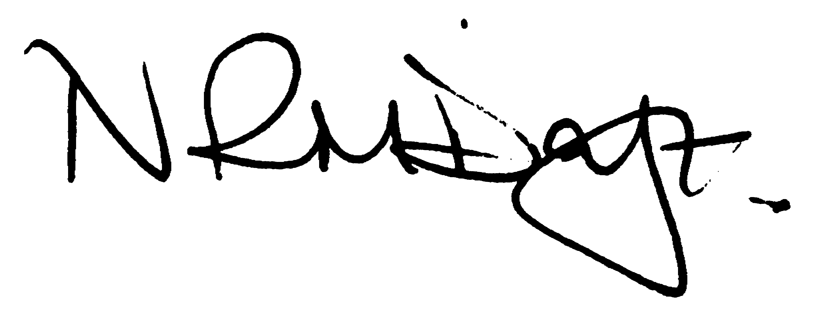

Nikki Daft – Parish Clerk

AGENDA

APOLOGIES AND ACCEPTANCE OF APOLOGIES

17/34 NOTIFICATION OF ANY DISCLOSABLE PECUNIARY INTERESTS OR OTHER INTERESTS
Only in respect of matters which are to be considered by members below. (Disclosures previously declared and registered need not be repeated).

17/35 PUBLIC QUESTIONS, POLICE REPORT AND NCC UPDATE

Public participation may continue until for 15 minutes after which the public must not take part at any other time during the meeting. Request should be made to the Chair if any member of the public wishes to make a recording of any part of the meeting. All audible sounds to be switched to silent unless otherwise agreed at the start of the meeting. A report only can also be given by the Police and NCC representatives

17/36 MINUTES - To approve the minutes of the meetings held on 28th June 2017 as a true record.

17/37 RESOLUTIONS AND ACTIONS - MATTERS FROM PREVIOUS MINUTES

- War memorial meeting – agenda item
- Section 50 licence – additional roads
- Leaflet re Hilton Hall
- Information regarding cleaning the War memorial – agenda item
- Hearing survey
- Sound system – agenda item
- Quotes regarding parsons hall car park trees – agenda item
- Recreation group meeting

17/38 FINANCIAL/POLICIES

- To Approve Payments for July & August 2017 (Clerk)
- To receive information regarding the current financial statement (Clerk)
- To agree the authorisation of the bacs payments

17/39 RECREATION GROUNDS

- To receive and agree the reports/repairs/damage to the recreation grounds (JD)

17/40 HIGHWAYS

- To agree any items that need to be added to the next agenda
- To receive a response for the Section 50 licence
- Enhancement Gang work carried out in the village
- To discuss the trimming of the trees near to no. 2 Arkwright Road

17/41 LITTLE IRCHESTER/KNUSTON - To agree the Highway Warden report, previously circulated. Matters arising will be added to the next agenda

- To discuss the parking problems within Little Irchester
- To discuss the repair and replanting of the village planter

17/42 PLANNING - To discuss any planning issues
- 17/00040/WASFUL – Land of Gipsy Lane Importation of inert waste materials
- WP/17/00382/FUL – Demolition of conservatory to single storey and two storey extension – 53 Gipsy Lane
- WP/17/00450/FUL - 2 storey extension to side of property -17 Grange Close, Irchester,
- WP/17/00478/FUL - Single storey side and rear extension. - 2 Manton Spinney, Knuston Spinney, Irchester,
- WP/17/00466/FUL - Extension and alteration to existing garage for conversion to 2 studio flats and integral parking
Garage Rear 41 Newtown Road, Milton Road, Little Irchester,
- WP/17/00469/FUL - First floor side and 2 storey rear extension - 14 Pine Close, Irchester
- WP/17/00434/FUL - Nine additions units to existing traveller site- Caravan Site, Gipsy Lane, Irchester
- WP/17/00464/FUL - Proposed 3 Bedroom & 2 Bedroom semi-detached dwellings with associated parking - re-submission - Land Between 75A And 75 B, High Street, Irchester, Wellingborough, Northamptonshire,
- WP/17/00507/FUL – Conversion for single detached house – Congregational Hall Lt Irchester
- WP/17//00542/FUL - Proposed Alterations and extension 57 Arkwright Road, Irchester
- WP/17/00541/FIL - Vehicular access 68 Station Road, Irchester
- WP/17/00519/FUL - Conversion of the existing redundant pump house into a facilities building for use by the associated fishing syndicate - re-submission following the refusal of WP/17/00058/FUL
Former Pump House, London Road, Little Irchester

17/43 NEIGHBOURHOOD PLAN - To receive an update on the progress of the NHP

17/44 CEMETERY/WAR MEMORIAL

- To receive the Registrars report and decide if details should be added to the next agenda
- To discuss the cleaning of the War Memorial (TM)
- To discuss the re organising of the war memorial garden

17/45 COMMUNITY ISSUES

- To discuss the registering of Community Assets – update
- To discuss the quotations for the trimming of the trees in the Parsons car park
- To discuss the quotation for removing the post for the village sign and replacing it with the new one
- To discuss suggestions for applying for Capital Funding from BCW
- To receive information from the Best Village Competition
- To discuss the Remembrance Day Services for Irchester and Little Irchester
- To receive information regarding a portable PA sound system for meetings and cost of equipment

17/46 CORRESPONDENCE To consider information received from incoming correspondence and decide on agenda items for the next meeting.

- To discuss the organising of a presentation to receive information on Unitary Councils from NCC.
- NCALC AGM members attending on 7th October 2017
- NCC Minerals and Waste Local Plan
- NCC grit bins

17/47 EXCLUSIVE TO PUBLIC AND PRESS

17/48 HILTON HALL LITTLE IRCHESTER

To discuss the Hilton Hall building and decide how the council should proceed

