
The Parish Council of Irchester
Clerk  Nikki Daft PSLCC  45 Park Road  Irthlingborough  Northants  NN9 5PW |  | Telephone 07525 909528  irchesterpc@gmail.com

Dear Councillor 15th April 2019

You are hereby summoned to attend the Ordinary meeting of Irchester Parish Council to be held in the Village Hall, School Road Irchester on Wednesday 24th April 2019 at 7.15p.m.

Yours faithfully
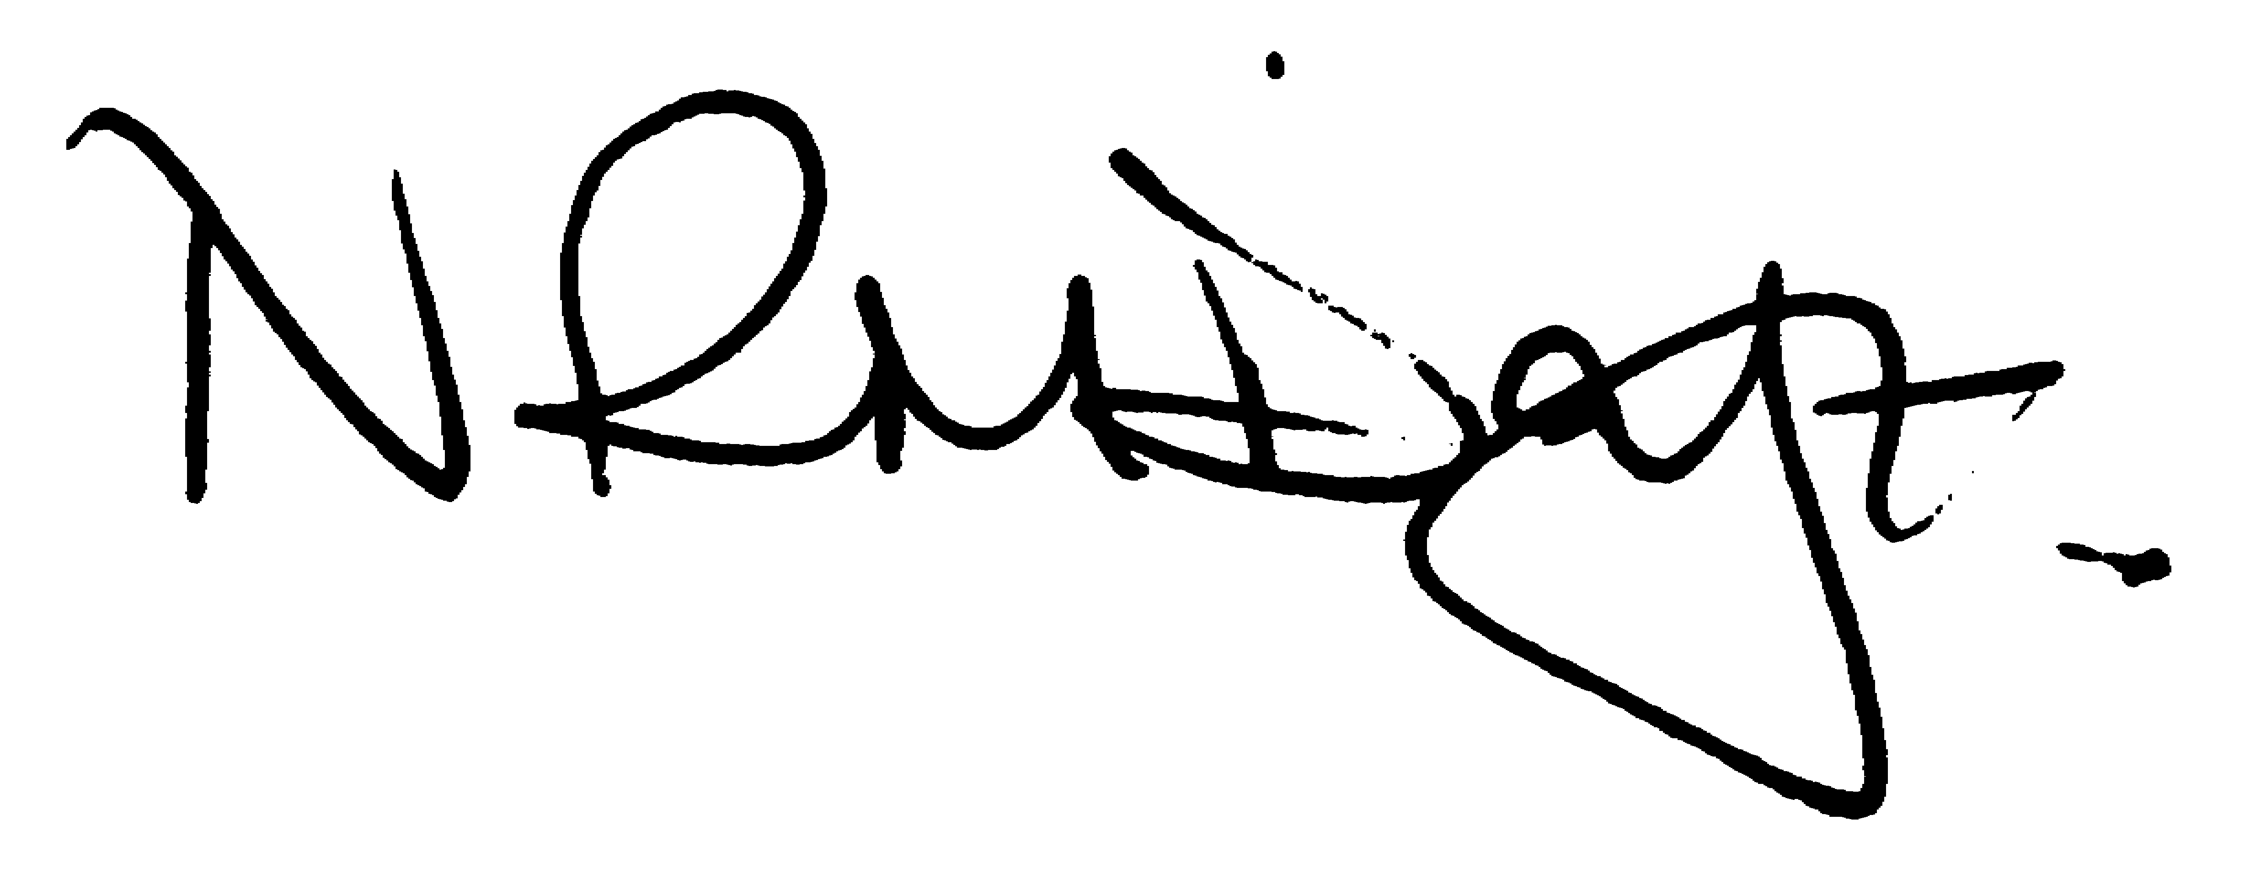

Nikki Daft – Parish Clerk

AGENDA

APOLOGIES AND ACCEPTANCE OF APOLOGIES

18/129 PUBLIC QUESTIONS AND/COMMENTS

Public participation may continue until for 15 minutes after which the public must not take part at any other time during the meeting. Any member of the public can make a recording of any part of the meeting. All audible sounds to be switched to silent unless otherwise agreed at the start of the meeting.

POLICE REPORT AND NCC UPDATE

To receive a verbal report from the Police and NCC representative if in attendance

18/130 NOTIFICATION OF ANY DISCLOSABLE PECUNIARY INTERESTS OR OTHER INTERESTS
Only in respect of matters which are to be considered by members below. (Disclosures previously declared and registered need not be repeated).

- To receive declarations of interest
- Councillors to declare any personal interest in any items on the agenda
- Councillors to declare any personal and/or prejudicial interest in any items on the agenda and to inform the Chairman if they wish to speak on the matter during public participation

18/131 MINUTES - To approve the minutes of the meetings held on 27th March 2019 as a true record.

18/132 RESOLUTIONS AND ACTIONS - MATTERS FROM PREVIOUS MINUTES

- Letters to M Griffiths, P Bone MP, Network Rail and Highways England re roads – responses from Network Rail, MP P Bone and Highways England
- Letter to BCW stating IPC expression of interest in Irchester library - acknowledged
- Eon 3 year fixed term for unmetered supply contract signed
- Write to lessees re grave mounds to be reduced
- Contact re memorial testing of headstones

18/133 FINANCIAL/POLICIES

- To Approve Payments for April 2019 details sent to councillors via email (Clerk)
- To receive information regarding the current financial statement – reconciliation statement sent to councillors via email (Clerk)
- To agree the authorisation of the bacs payments
- To discuss the renewing of the contract for the maintenance of St Katherine’s church clock
- To agree the Annual Governance for the External Auditor and receive the Internal Auditors Report for the accounts ending 2018/19
- To approve AGAR section 1
- To approve AGAR section 2

18/134 RECREATION GROUNDS

- To receive and agree the reports/repairs/damage to the recreation grounds (JD)
- Request to use the recreation ground on Saturday mornings and Wednesdays for a boot camp

18/135 HIGHWAYS

- To agree any items that need to be added to the next agenda

18/136 LITTLE IRCHESTER/KNUSTON - To agree the Highway Warden report. Matters arising will be added to the next agenda.

18/137 CEMETERY/WAR MEMORIAL/GARDENS

- To note the information from the Cemetery Working Party and decide if any item needs to be added to the next agenda
- To decide the date for levelling the graves
- To discuss when the memorial headstones will need to be tested and agree the memorial testing policy and signage to be placed in the village voice and cemetery notice board

18/138 PLANNING

- Application No. WP/19/00139/FUL Proposal: Conservatory to side of dwelling Location: 70 Woodlands Road, Irchester, Wellingborough, Northamptonshire, NN29 7BU
- Application No. WP/19/00001/FUL Proposal: The retention of an existing Network Rail vehicle track and compound , Location: Land Off Ditchford Road, Irchester, Northamptonshire
- Application No. WP/19/00183/FUL Proposal: Single storey rear extension (amended scheme following approval of WP/19/00014/FUL) Location: 49 Gipsy Lane, Irchester, Wellingborough, Northamptonshire, NN29 7DJ
- Application No. WP/19/00154/OUT Proposal: Outline application for up to 75 dwellings including new vehicular access off Farndish Road, with areas of landscaping and public open space, land for a community facility, and associated infrastructure works (access only to be determined at this stage) Location: Land Adjacent 79-81 Farndish Road And Rear 2 To 26 James Street, Farndish Road, Irchester, Wellingborough, Northamptonshire,

18/139 COMMUNITY/CONSULTATIONS EVENTS

- To receive a information from the Village Voice Working Party and decide if any item needs to be added to the next agenda
- To receive information regarding the setting up of a management group for the library
- To receive information from the Parsons Hall working party

18/140 CORRESPONDENCE To consider information received from incoming correspondence and decide on agenda items for the next meeting.

