IRCHESTER PARISH COUNCIL

Minutes of the Ordinary Meeting of the Parish Council held on Wednesday 28th August 2024 at the Village Hall, School Road at 7.15p.m.

Members Present:
K Watts – In the Chair

Councillors
P Armstrong A Hurley J-P Carr A Howden M May S East
P Smith D Schroll G Brotherston I Macdonald

The meeting started at 7.15pm. There were 2 members of the public present including NNC Cllr M Griffiths

Apologies - Ben Leeson accepted

24/29 Notification of Any Interests

None declared

24/30 Public Questions, Police Report and NNC Update

Public – No questions raised

Police – no report – it was stated that there had been an issue of drug dealing in Little Irchester which had been reported but no further update

NNC Update – Leaders report sent to councillors.
- Consultation on polling stations
- New Finance Director appointed
- Peer Review of NNC services from other councillors
- Review of the Planning Performance ongoing

24/31 Minutes

RESOLVED - The minutes from 26th June 2024 meeting were agreed as a true record and signed by the Chair.

24/32 Financial Matters

- Payments – RESOLVED: That the payments for £15019.76 for July and August 2024 were approved. Directs Debit payments pending Yu Energy & Hugo Fox and late payment for PKF Littlejohn £504.00

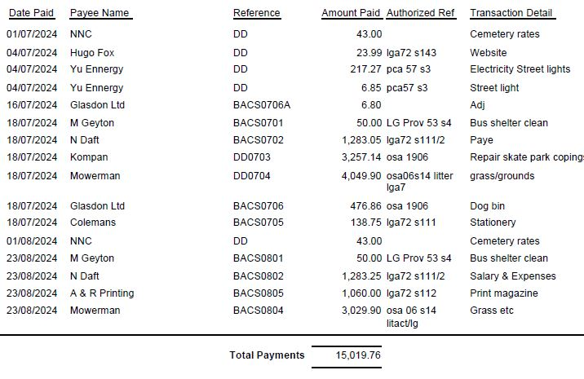

- The Current financial statement after the payments, but not including the DD’s, being £249,605.50
- RESOLVED that Cllrs P Smith & P Armstrong to authorise the bacs payments for August 2024.
- The external Auditors report had been received with no comments or actions given. The Clerk was thanked for completing the accounts successfully.

24/33 Recreation Grounds

- Discussion took place regarding the ground and the key holders of the gate. It was suggested that a more formal agreement with the Romans football team be in place of which the pc representatives will discuss with the Sports Association(SA). The representatives were also asked for a list of key holders for the recreation gate however SA committee members stated no one had keys. It was agreed that a new lock with non copying keys should be purchased and a key holders log introduced. Action Clerk
- Discussion took place regarding a tribute to the late Cllr Maguire. Several suggestions were made regarding the sports club of which the council representatives suggested at the Sports Association meeting. It was agreed by the SA to have a trophy/cup for indoor sport that would be held at Christmas time. It was agreed to contact the SA regarding wording. SO suspended for Cllr M Griffiths to speak regarding the tribute to Cllr Maguire. SO resumed Action Clerk
- It was noted that the Sports Association were concerned regarding the lease as it was due to expire within a few years. Agreed Clerk to contact the Chair Action Clerk
- It was stated that the annual play inspection by Wicksteed had been delayed and would be carried out asap.
- RESOLVED to purchase cradle swing in the recreation ground which is broken and needed replacing.

24/34 Highways

- It was noted that a new issues had been reported to fixmystreet regarding weeding of gullies and side road which had been taken down by them and re reported. There was an issue with a privately owned alleyway where a fence is looking dangerous. This to be reported through the planning portal. Action Clerk
- Discussion took place regarding replacing the seat at the corner of Bakers Crescent. It was suggested that further information is required regarding if the family are happy for a seat so council can discuss where it would be situated. Action AH
- It was RESOLVED to accept the quotation to have the street light repaired in Austin Close. Action Clerk

24/35 Cemetery/War Memorial

It was agreed to order the memorial testing for October once the cutting season has finished. Action Clerk
It was agreed that a Working Party be set up to organise the Remembrance Day Service with ex service personnel.
Action JP

24/36 Planning

- NW/24/00409/FUL – Detached garage Home Farm Cottage 19 Knuston Road – No objections Action Clerk

24/37 Correspondence

- Letter received regarding the junction of London End and Farndish Road – to await details from NNC regarding areas for consideration
- Consultation re Green Hill Solar Farm NW/24/00448/EXT – suggest details sent to Wollaston Library and local newspapers Suspend SO – Cllr M Griffiths – size 3000 acres are extended surrounds villages with conservation areas. Not currently a planning application but will be determined by central government. Concern regarding loss of agricultural land. Locals have organised a petition and several councillors are concerned regarding the size. SO resumed Action Clerk

24/38 Exclusive to Public and Press

RESOLVED: That pursuant to the Public Bodies (Admission to Meetings) Act 1960, the public and press is excluded from the meeting for the item of business on the grounds that publicity would be prejudicial to the public interest by reason of the confidential nature of the business to be discussed.

24/39 Staff

It was stated that there had been 4 applicants for the position with a variation of experiences however 3 had found other positions within the sector. An interview will take place and if suitable it was agreed to employ the candidate. If not the position would be readvertised as suggested via NCALC with change in salary scale and hours.
RESOLVED that current Clerk take on the position of Cemetery, H & S, Contractors and Projects for 10 hours per week.

Meeting closed at 9.05 pm

Chair

These minutes are draft until agreed at the next full council meeting

