IRCHESTER PARISH COUNCIL

Minutes of the Ordinary Meeting of the Parish Council held on Wednesday 25th January 2023 at the Village Hall, School Road at 7.15p.m.

Members Present:
K Watts – In the Chair

Councillors
P Smith L Brown JP Carr T Maguire S Bridge
C Ashford M May S East D Shroll K Clarke S Vassell

The meeting started at 7.15pm. there were 46 members of the public present.

Apologies - Agreed and Accepted from Cllrs J Dunkley
Apologies noted Cllr P Armstrong
Absent Cllr V Blake

Apologies were also received from NNC Councillors M Griffiths and T Partridge-Underwood

22/79 Public Questions, Police Report and NNC Update

Block paving – request was made that all the block paving be gritted in the village – It was advised that NNC highways is responsible for the footpaths however the pc do grit the area around School Road for the school run on a regular basis. Further grit bins were suggested to be placed near to the block paving.

Concern was raised regarding parking near to the junction in Prospect Avenue. Highways to be contacted regarding possible solutions.

Highways – several members of the public voiced concerns regarding the speeding within the village. The police and NNC highways had been contacted regarding this, of which no one could attend the meeting, however it was suggested that a further meeting be held with residents and highways in order to investigate what traffic calming procedures were possible.

It was stated there had been some confusion with the waste bin collections as NNC had not communicated the procedure clearly.

Standing Orders were suspended to allow the public another 15 minute session

Police Report – details sent to councillors

NNC Report – no updates to report. Query was raised regarding the NNC tree policy but no update was available.

Standing Orders were resumed

22/80 Notification of Any Interests

Cllr May declared a new interest regarding the Methodist Church

22/81 Minutes

The minutes from 13th December 2022 were agreed as a true record to be signed by the Chair.

22/82 Financial Matters

- Payments – Resolved: That the payments for December of £10,027.92 and £6984.99 for January 2023 be approved.
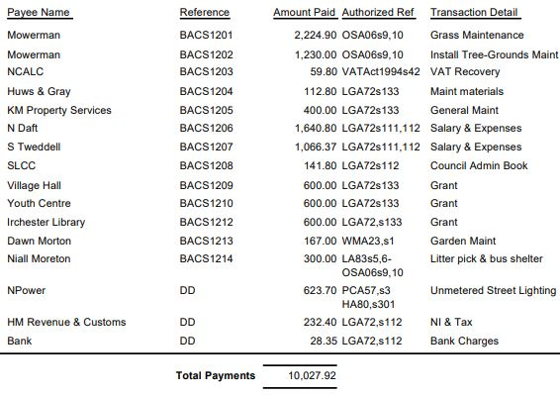
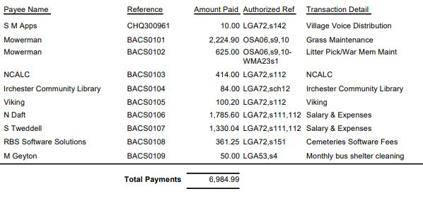
- The Current financial statement after the payments being £197,313.14
- RESOLVED that Cllrs L Brown and JP Carr to authorise the bacs payments for January 2023
- A contribution only had been received from the Bowls Club towards the white lines for the car park.

22/83 Cemetery/War Memorial

- There had been a few interments within the cemetery. An issue had arisen with a grave digger and a damaged headstone which was being investigated by the funeral director. The Cemetery Officer was thanked for all her help in the smooth operating of cemetery matters.

22/84 Highways

- Highways issues – with regards to the public concerns councillors were advised of the traffic data and crash sites for the past 5 years and also an explanation from highways regarding certain traffic calming issues. The police had stated that they would be carrying out a further traffic data survey in February/March of this year.
- Damaged had been caused to a Perspex window of the bus shelter in Wollaston Road. It was resolved that the aperture be replaced with a board.

22/85 Play Areas
- There had been a meeting with Wicksteed regarding the replacement of the Billbox in Little Irchester and a new piece of equipment. It was RESOLVED to accept the quotation of £17,964.66 to have the new equipment installed. Funds to be received from the dissolution of 1-100 club will also be used towards the new equipment.

22/86 Community Projects

- Orchard – The new trees and bulbs were waiting to be planted once the weather improved. There had been some damage received to one of the trees
- Library – There had been a few more volunteers trained. Rhymetime to commence in the library on Thursday mornings and the police to hold 2 surgeries. Notices will be placed on the pc notice boards for resident information.
- A meeting had taken place with Mulberry Homes regarding the public open space. The play equipment previously discussed was still scheduled to be wooden of which a request was made to alter to steel. The pc requested that the fence around the SUDS remain and access of a gate be placed near to the electric station. It was agreed that the low level fence for the community land have a staggered opening to allow access from the estate.

.22/87 Planning

The following planning applications were discussed:

- NW/22/00619/VAR – 130C High Street, Irchester, Wellingborough, NN29 7AB – Proposal: Removal of condition 3 on planning permission reference WP/2002/0367/F - which restricts 'The annexe accommodation hereby approved shall always remain ancillary to the main residential unit on the site and shall not be subdivided from it so as to create its own planning unit' updated application form, amended plan and additional plan to show the parking/access arrangements. – It was agreed to object to this application on the grounds that there is insufficient parking.
- NW/22/00880/LBC – High Farm, 400 Station Road, Irchester, Wellingborough, NN29 7EY – Proposal: Listed Building Consent for the demolition of the attached lean-to structures to centralised brick building (former cottage) and extension and conversion to form a three bedroom residential dwelling – No objections
- NW/22/00819/FUL – Chester House, Higham Road, Irchester, Wellingborough, NN29 7EZ - Retrospective application for the change of use of B16 (Farmhouse) and B10 (Barn) to host wedding license. No internal or external changes are to be made to either building. The buildings are already used to host events and wedding receptions. – No objections
- NW/23/00005/LBC - 1A London End, Irchester, Wellingborough, NN29 7BH - Proposal: Listed Building Consent for the partial like-for-like re-wiring and upgrading of electrical services and installation of new consumer unit to meet current regulations and improve energy efficiency. – No objections

22/88 Correspondence

Information had been received from NNC regarding two open days for Knuston Hall on 30th and 31st January 2023.

22/89 Exclusive to Public and Press

RESOLVED: That pursuant to the Public Bodies (Admission to Meetings) Act 1960, the public and press is excluded from the meeting for the item of business on the grounds that publicity would be prejudicial to the public interest by reason of the confidential nature of the business to be discussed.

22/90 Village Voice

Further discussion took place regarding the production of the Village Magazine. It was agreed for staff to produce the March edition will details being reviewed for the following edition.

The Clerk and Community Projects Officer left the meeting

22/91 Staff Roles

It was recommended from the Staff Working Party to offer the current Clerk the position of Assistant Clerk for 10 hours per week, at her request, with a 6 month probationary period and to re appoint the previous Clerk at 15 hours per week.

Meeting closed at 9.55 pm

Chair

