IRCHESTER PARISH COUNCIL

Minutes of the Ordinary Meeting of the Parish Council held on Wednesday 30th April 2025 at the Village Hall, School Road at 7.15p.m.

Members Present:
K Watts – In the Chair

Councillors
A Hurley J-P Carr P Smith G Brotherston I McDonald
P Armstrong M May B Leeson A Howden D Shroll J Dunkley

The meeting started at 7.15pm. There was 2 members of the public present.

A minute silence was held as a mark of respect for the late Cemetery Officer N Daft.

Apologies – None.

- Notification of any Interests

None declared.

- Public Questions, Police Report and NNC Update
Public – A query was raised relating to the play equipment repairs and further request raised for speed van to be present in the village.

Police – Report received and sent to Cllrs prior to the meeting. PCSO in attendance explained report and answer questions raised. The PCSO left the meeting following this item at 7.33pm.

NNC Update – Apologies received from Cllr Tom Partridge-Underwood. Leader’s report sent to councillors.

- Minutes
  - RESOLVED - The minutes from 26th March 2025 meeting was agreed as a true record and signed by the Chair.

- Financial/Policies
  - Payments – RESOLVED to agree the payments for April 2025 as listed below, totalling £8,149.82
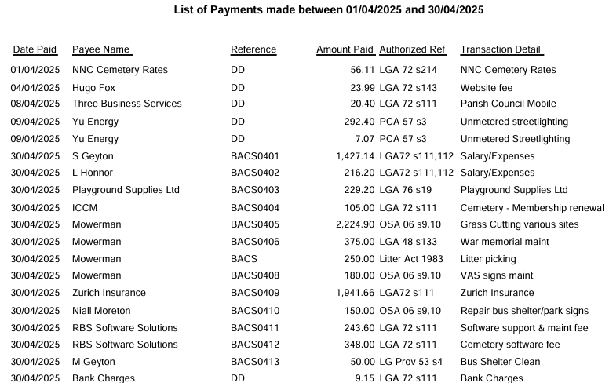
  - The Current financial statement after the March payments £192,276.25. The Clerk advised the precept had been received and would be noted in the next statement, also the VAT reclaim has been submitted and pending payment.
  - RESOLVED that Cllrs JP Carr & B Leeson to authorise the bacs payments for April 2025.
  - Year-end reports were sent to councillors with no concerns raised. Chair extended thanks to the Clerk for all working producing reports and working with Internal Auditor.
  - Internal Audit Report was sent to councillors with a couple of issue raised, new procedures are being implemented by the Clerk going forward.
  - RESOLVED Section 1 of the AGAR was agreed by Council
  - RESOLVED Section 2 of the AGAR was agreed by Council
  - RESOLVED to approve the training course for the Clerk

- Recreation Grounds
  - No new updates. Clerk to chase up quotations for wet pour repairs and also advised the new handles for broken equipment in the play area on Wollaston has been received and to be fitted.
  - RESOLVED to accept the request from Taylors Amusements to use the recreation ground from 22nd June subject to completed risk assessments and current insurance.

- Highways
  - Litte Irchester fly tipping issue raised.

- Cemetery/War Memorial
  - No report received for April.

- Planning
  - To note the below comments for the following planning applications received by NNC

Application No: NW/25/00134/FUL
Proposal: Part two storey part first floor extension and related internal alterations.
Location: 64 Arkwright Road, Irchester, Wellingborough, NN29 7EF.

No comments from the council.

  - No decisions to note from NNC.

- Correspondence
  - No additional correspondence received all emailed to councillors prior to the meeting.

- Exclusive to public and press

RESOLVED: That pursuant to the Public Bodies (Admission to Meetings) Act 1960, the public and press is excluded from the meeting for the item of business on the grounds that publicity would be prejudicial to the public interest by reason of the confidential nature of the business to be discussed.

- Staff matters
  - RESOLVED for delegated powers to be given to the staff working party to update Cemetery Officer job description and to advertise in all local medias. Once applications received interviews to be conducted and then bring recommendations to the full council to decide on appointment.

- Cemetery matters
  - Clerk updated the council on the recent cemetery matters.

Meeting closed at 9.08pm Chair 21st May 2025

