
The Parish Council of Irchester
Clerk  Nikki Daft PSLCC  45 Park Road  Irthlingborough  Northants  NN9 5PW |  | Telephone 07525 909528  irchesterpc@gmail.com

Dear Councillor 21st November 2018

You are hereby summoned to attend the Ordinary meeting of Irchester Parish Council to be held in the Village Hall, School Road Irchester on Wednesday 28th November 2018 at 7.15p.m.

Yours faithfully
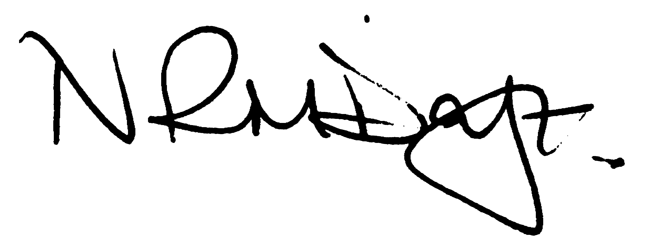

Nikki Daft – Parish Clerk

AGENDA

APOLOGIES AND ACCEPTANCE OF APOLOGIES

18/75 PUBLIC QUESTIONS AND/COMMENTS

Public participation may continue until for 15 minutes after which the public must not take part at any other time during the meeting. Any member of the public can make a recording of any part of the meeting. All audible sounds to be switched to silent unless otherwise agreed at the start of the meeting.

POLICE REPORT AND NCC UPDATE

To receive a verbal report from the Police and NCC representative if in attendance
To receive an update from the recent JAG meeting

18/76 NOTIFICATION OF ANY DISCLOSABLE PECUNIARY INTERESTS OR OTHER INTERESTS
Only in respect of matters which are to be considered by members below. (Disclosures previously declared and registered need not be repeated).

- To receive declarations of interest
- Councillors to declare any personal interest in any items on the agenda
- Councillors to declare any personal and/or prejudicial interest in any items on the agenda and to inform the Chairman if they wish to speak on the matter during public participation

18/77 MINUTES - To approve the minutes of the meetings held on 31st October 2018 as a true record.

18/78 RESOLUTIONS AND ACTIONS - MATTERS FROM PREVIOUS MINUTES

Planning responses – completed Solar light – installed Letter to Players - sent
Police – letter sent Grit bin licence – sent Rota – completed
Damaged seat – sorted Quotations – requested Tree trimming - orderes

18/79 FINANCIAL/POLICIES

- To Approve Payments for November 2018 details sent to councillors via email (Clerk)
- To receive information regarding the current financial statement – reconciliation statement sent to councillors via email (Clerk)
- To agree the authorisation of the bacs payments
- To discuss the purchasing of 11th Edition of Council Administration Charles Arnold Baker(Clerk)
- To agree the precept requirement for 2019/2020

18/80 RECREATION GROUNDS

- To receive and agree the reports/repairs/damage to the recreation grounds (JD)

18/81 HIGHWAYS

- To agree any items that need to be added to the next agenda
- To discuss the use of the recreation ground by horse and carts and to determine if the boundary can be improved (RE)

18/82 LITTLE IRCHESTER/KNUSTON - To agree the Highway Warden report. Matters arising will be added to the next agenda.

18/83 PLANNING - To discuss any planning issues

- WP/18/00675/FUL - Proposal: Proposed 2 bedroom detached bungalow adjacent to 2 Wollaston Road,
Irchester - re-submission 2 Wollaston Road, Irchester, Wellingborough, Northamptonshire, NN29 7DE
- Application No. WP/18/00698/FUL Proposal: Erection of single storey side extension Location: 14 School Hill, Irchester, Wellingborough, Northamptonshire, NN29 7AN
- Application No. WP/18/00688/FUL
Proposal: Erection of 1no. bungalow with associated garden area and parking Location: Land To The Rear Of, 31 Edward Road, Irchester, Wellingborough,
Northamptonshire, NN29 7BN

18/84 CEMETERY/WAR MEMORIAL/GARDENS

- To note the report from the Cemetery Working Party and decide if any item needs to be added to the next agenda

18/85 COMMUNITY/CONSULTATIONS EVENTS

- To receive a report from the Village Voice Working Party and decide if any item needs to be added to the next agenda

18/86 CORRESPONDENCE To consider information received from incoming correspondence and decide on agenda items for the next meeting.

- Email from resident regarding CCTV
- Email regarding the mobile visit in 2019 of Rural Information Centre
- Invite to the Parish Forum 4th December 2018

18/87 EXCLUSIVE TO PUBLIC AND PRESS

18/88 LIBRARY

- To discuss the offers sent from NCC regarding the library
- To receive information from the consultant regarding the Business Plan
- To discuss members of the Library working party

