
The Parish Council of Irchester
Clerk  Nikki Daft MILCM  45 Park Road  Irthlingborough  Northants  NN9 5PW |  | Telephone 01933 384180  Parishclerk123@gmail.com

Dear Councillor 18th January 2016

You are hereby summoned to attend the Ordinary meeting of Irchester Parish Council to be held at Village Hall, Irchester on Wednesday 27th January 2016 at 7.15p.m.

Yours faithfully
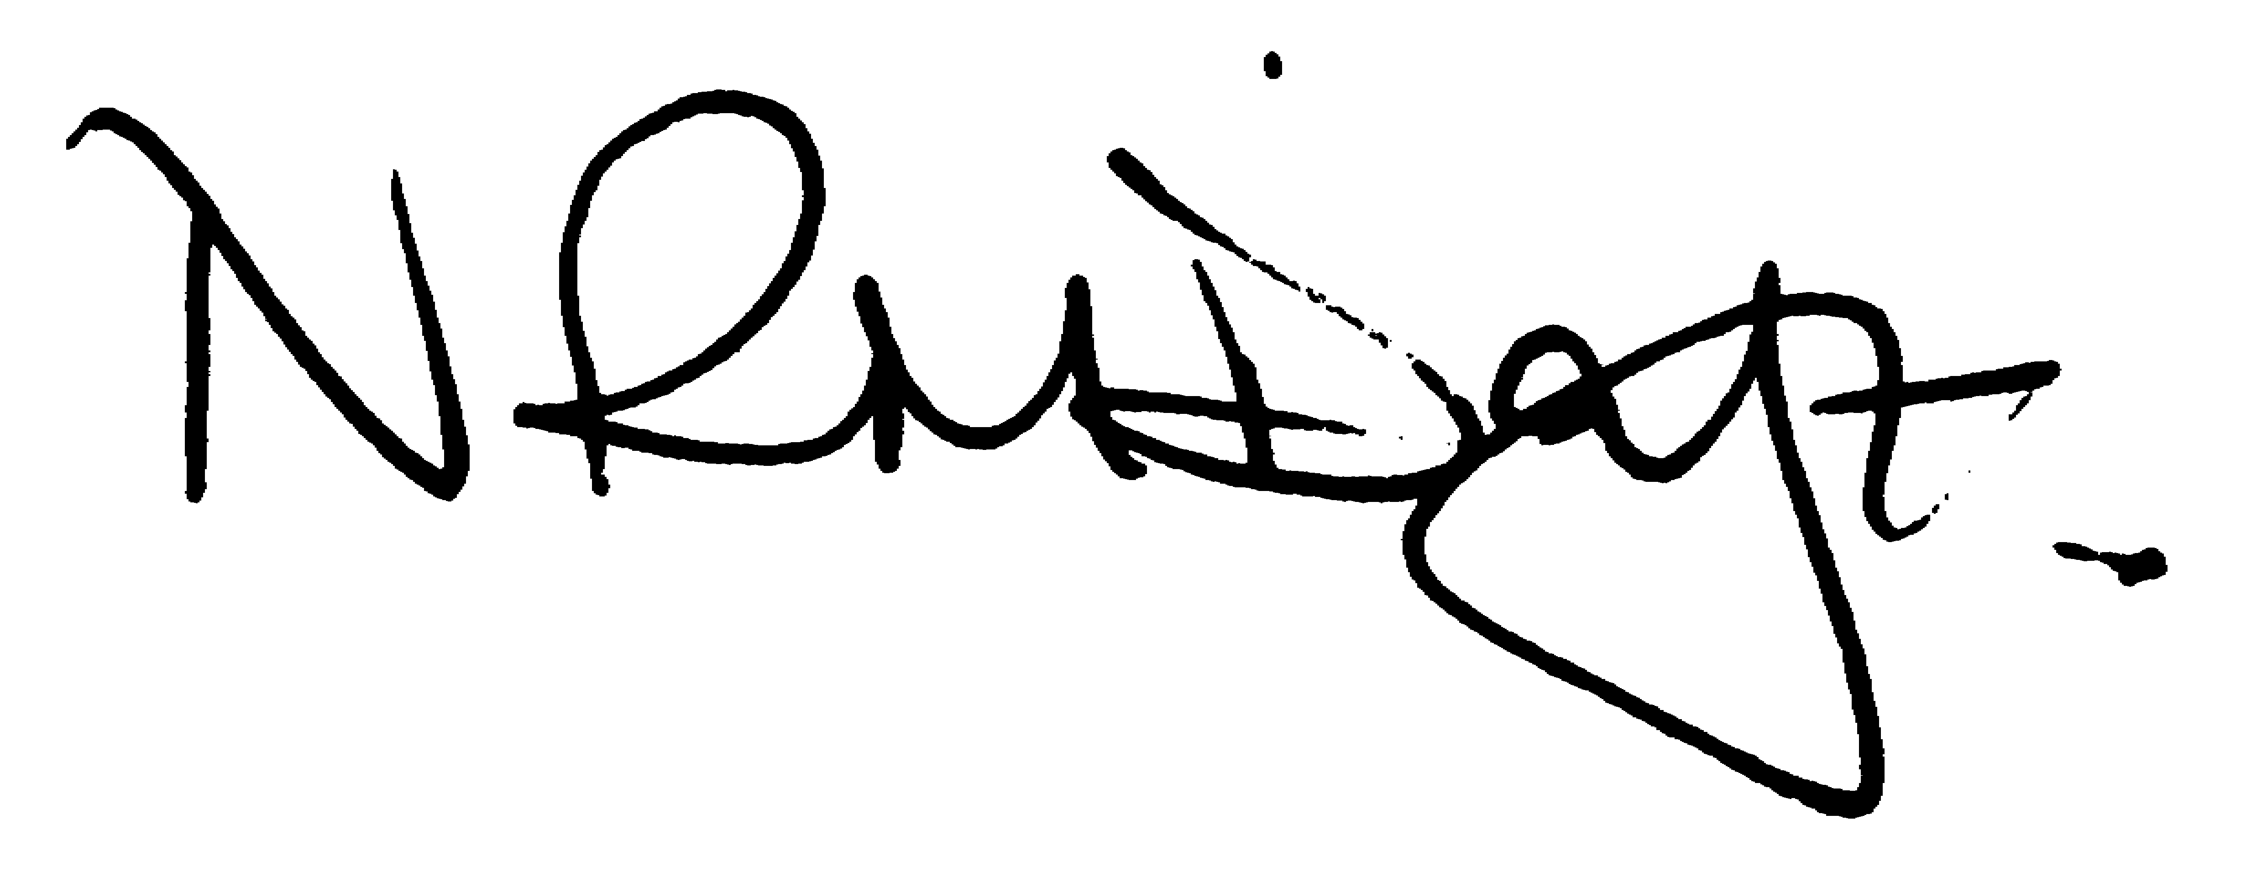

Nikki Daft – Parish Clerk

AGENDA

APOLOGIES AND ACCEPTANCE OF APOLOGIES

15/86 NOTIFICATION OF ANY DISCLOSABLE PECUNIARY INTERESTS OR OTHER INTERESTS
Only in respect of matters which are to be considered by members below. (Disclosures previously declared and registered need not be repeated).
• To receive written requests for dispensations for disclosable pecuniary interests (if any)
• To consider any requests for dispensations as appropriate

15/87 MINUTES

a) To approve the minutes of the meetings held on 25th November 2015 as true records

15/88 PUBLIC QUESTIONS, POLICE REPORT AND NCC UPDATE

Public participation may continue until for 15 minutes after which the public must not take part at any other time during the meeting. Please note that the meeting maybe recorded. All audible sounds to be switched to silent unless otherwise agreed at the start of the meeting. A report only can also be given by the Police and NCC representatives

15/89 RESOLUTIONS AND ACTIONS - MATTERS FROM PREVIOUS MINUTES
Agenda | Task | By | Completed/comments
Nov | Parking School Road write NCC | Clerk | Sent
 | Play equipment removal | Clerk | Completed
 | Footpaths Arkwright | Clerk | Reported St Dr

15/90 FINANCIAL/POLICIES

- To Approve Payments for December 2015 and January 2016 (Clerk)
- To receive information regarding the current financial statement (Clerk)
- To agree the authorisation of the bacs payments
- To confirm that the council will remain opted-in to the Sector Led Body arrangements for the procurement of external audit.
- To discuss procurement details in section11 of Financial Regulations and to decide if any changes need to take place
- To review lengths man job list for February 2016

15/91 RECREATION GROUNDS

- To receive and agree the reports/repairs/damage to the recreation grounds
- To discuss the problem with the poached area to the recreation ground from Alfred Street and determine what course of action can be taken to prevent/manage it.
- To receive a quotation regarding moss treatment of the wetpore that is currently covered in algae

15/92 HIGHWAYS

- 759473 - Footpaths in poor state cut through from Arkwright Road to Denton Close uneven for pushchairs and mobility scooters etc. – this is under investigation
- NCC response re School Lane
- To discuss the request for yellow lines along a section of School Road
- To receive information regarding the Borough Councillors Spring Clean event

15/93 LITTLE IRCHESTER/KNUSTON

- To agree the Highway Warden report. Matters arising will be added to the next agenda

15/94 PLANNING

To receive an update on planning matters

- WP/15/00774 – Conversion of garage to annex – 6 School Hill
- WP/15/00806 – Rear & Side Extension – 1 Larch Close
- WP/15/00808 – Change of use stable building to residential – 77 High Street
- WP/16/00007 – 2 Storey side extension – 149 Bradshaw Way

15/95 NEIGHBOURHOOD PLAN

- To receive an update on the NH Plan

15/96 CEMETERY/WAR MEMORIAL

- Registrar report – matters for next agenda

15/97 CORRESPONDENCE

To consider information received from incoming correspondence and decide on agenda items for the next meeting

- Correspondence received regarding parking in Arkwright Road
.

