
The Parish Council of Irchester
Clerk  Nikki Daft  45 Park Road  Irthlingborough  Northants  NN9 5PW |  | Telephone 07525909528  irchesterpc@gmail.com  www.hugofox.com/community/irchester-parish-council-13388/about-us

Dear Councillor 18th April 2023

You are hereby summoned to attend the ordinary meeting of Irchester Parish on Wednesday 26th April 2023 at 7.15p.m.at the Village Hall, School Road, Irchester

Yours faithfully
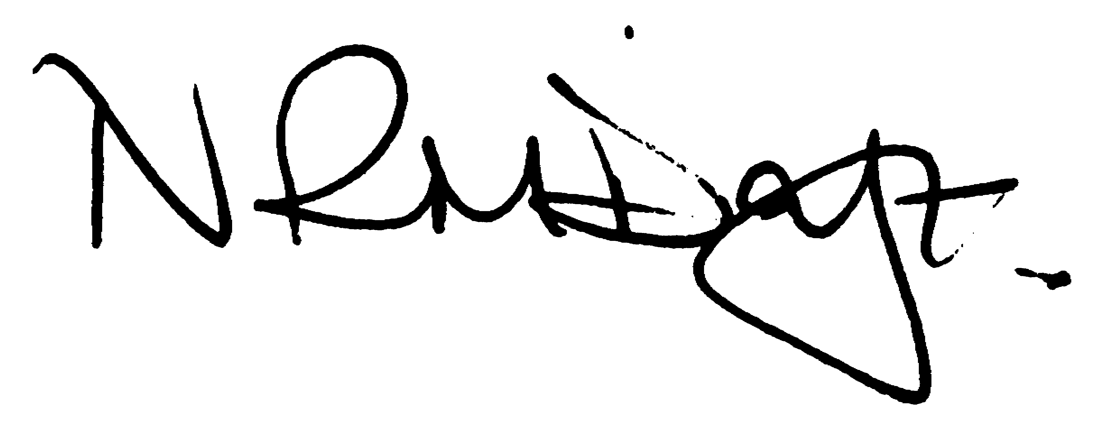

Nikki Daft – Parish Clerk

AGENDA

APOLOGIES AND ACCEPTANCE OF APOLOGIES

22/113 PUBLIC QUESTIONS, POLICE REPORT AND NNC UPDATE

Public are requested to send specific questions to council prior to the meeting due to time constraints

22/114 NOTIFICATION OF ANY DISCLOSABLE PECUNIARY INTERESTS OR OTHER INTERESTS
Only in respect of matters which are to be considered by members below. (Disclosures previously declared and registered need not be repeated).

- To receive declarations of interest
- Councillors to declare any personal interest in any items on the agenda
- Councillors to declare any personal and/or prejudicial interest in any items on the agenda and to inform the Chairman if they wish to speak on the matter during public participation

22/115 MINUTES

a) To approve the minutes of the meeting held on 29th March 2023 as a true record.

22/116 FINANCIAL/POLICIES

- To Approve Payments for April (RFO)
- To receive information regarding the current financial statement (RFO)
- To agree the authorisation of the bacs payments
- To receive the year end reports for 2022/23
- To receive the Internal Audit report
- To agree Section 1 of the AGAR
- To agree Section 2 of the AGAR

22/117 CEMETERY/WAR MEMORIAL

- To receive an update on cemetery matters
- To discuss the cost of a push tap for the cattle trough

22/118 HIGHWAYS

- To receive an update on any Highways issues
- To receive the response from the MP regarding the installation of a post box on the corner of Wollaston Road and School Road

22/119 PLAY AREAS

- To receive an update regarding the play areas

22/120 COMMUNITY

- To receive a report from the community orchard.(KW)
- To receive an update on the library.(JPC)
- To discuss the placing of a new bench opposite the war memorial and response from Mulberry Homes

22/121 PLANNING

NW/23/00201/FUL Proposed new driveway and dropped kerb from Wollaston Road to serve existing property. Location: 132 Wollaston Road Irchester Wellingborough NN29 7DH

22/122 CORRESPONDENCE

To discuss items required for the next agenda.

22/123 EXCLUSIVE TO PUBLIC AND PRESS

To agree to discuss the following item exclusive to public and press

22/124 UPDATE ON AUSTIN CLOSE PROMOTION AGREEMENT

To discuss further information regarding the proposed promotion agreement

