IRCHESTER PARISH COUNCIL

Minutes of the Ordinary Meeting of the Parish Council held on Wednesday 29th March 2023 at the Village Hall, School Road at 7.15p.m.

Members Present:
P Armstrong– In the Chair

Councillors
P Smith L Brown JP Carr T Maguire S Bridge K Watts
C Ashford M May D Shroll K Clark V Blake

The meeting started at 7.15pm. There were 10 members of the public present.

Apologies - Agreed and Accepted from Cllrs J Dunkley, S East & S Vassell

22/101 Public Questions, Police Report and NNC Update

Public: Concern was raised from the public for the following:

Query regarding hay spillage in the village blocking gullies and drains. Asked if an alternative route can be considered.

Parking on the footpath along Wollaston Road – Police to be informed (ST)

Police Report – details sent to councillors. Police surgery to be held at the library on 1st April

NNC Report – As per the Leaders newsletter previously sent to councillors which includes:
Free Swim during Easter holidays for under 18’s, Tourism hub in Rushden Lakes open, Street party road closures deadline and Armed Forces Covenant signed

22/102 Notification of Any Interests

None declared

22/103 Minutes

The minutes from 22nd February 2023 were agreed as a true record to be signed by the Chair.

22/104 Financial Matters

- Payments – Resolved: That the payments for £34,491.12 for March 2023 were approved.

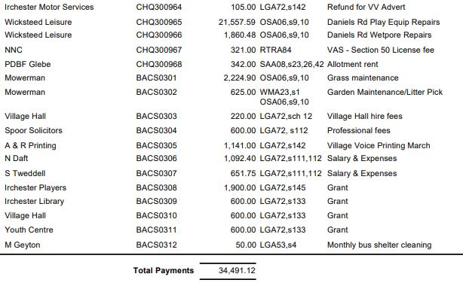

- The Current financial statement after the payments being £154,203.68
- RESOLVED that Cllrs P Smith and P Armstrong to authorise the bacs payments for March 2023
- RESOLVED to continue with a deemed contract with Npower for the time being.

22/105 Cemetery/War Memorial

- Grass cutting started last week.
- Issue with the water cattle trough as the ball cock has stopped working. To look at the possibility of installing a press top tap.

22/106 Highways

It was stated that pot holes which had been reported to fixmystreet were not being fixed until August so any damaged caused to vehicles should be reported to NNC.

- Highways issues – The Highways WP had met and the following recommendations were received:
  - To increase the number of VAS for the village – It was agreed to apply for funding to the Police Commissioners Officers before considering purchasing new signs.
  - To write to NNC and ask that the secondary school bus route be changed so that the children did not have to cross over Wollaston Road when there was heavy traffic
- The street light in Sharwood Terrace was no longer working and needed to be upgraded. RESOLVED to accept the quotation of £2344.90.and replace the light
- A response had been received from the PO regarding placing a letter box on the corner of Wollaston Road and School Road however this was declined by them. It was suggested to write to the MP to see if he could help the matter.

22/107 Play Areas
- The order for the new play equipment for Little Irchester Daniels Road had been installed and the plaques ordered regarding the donation from 1-100 club. A grant for £5000 had been applied for from NNC which had been successful.
- RESOLVED to replace the Fido Dog Bin on the recreation ground at a cost of £268.09 plus fixing and fitting.

22/108 Community Projects

- Orchard – the new trees which had been planted were doing well. There were now apple, pear, plum and cherry trees now in the orchard. The bulbs were also growing well. The raised beds are in the process of being built which are free of charge to the council.
- Library – Volunteers had had a meeting to discuss details in the library and funding raising ideas were being planned. A Spring Fayre to take place on 1st April. Rhyme time was doing well and the Warm Space was due to end in March.
- King Charles III coronation – volunteers asked to add bunting to the village and to also decorate Station Road corner. PR company from Mulberry Homes have asked if they can support
- Bench – discussion took place regarding replacing the bench opposite the War Memorial. It was agreed to contact Mulberry Homes PR to see if they could help sponsor the bench
- Discussion took place regarding signing the Armed Forces Covenant. It was agreed to sign the document.

22/109 Planning

- NW/23/00127/FUL Proposed single storey side extension. 6 Woodlands Road, Irchester – No comment
- NW/23/00145/FUL Internal alterations and extensions, conversion/rebuilding of out buildings to kitchen, conservatory, front porch and new retaining wall – 109 High Street Irchester – No comment stone to be reused for a retaining wall.

22/110 Correspondence

Details received from NNC regarding the Public Space Anti-Social Order. It was agreed to ask for several areas of the village to be included in the Order.

22/111 Exclusive to Public and Press

RESOLVED: That pursuant to the Public Bodies (Admission to Meetings) Act 1960, the public and press is excluded from the meeting for the item of business on the grounds that publicity would be prejudicial to the public interest by reason of the confidential nature of the business to be discussed.

22/112 Promotion Agreement

Details regarding the proposed Promotion Agreement were discussed and it was agreed to contact the new solicitor for further advice.

Meeting closed at 8.50 pm

Chair

