
IRCHESTER PARISH COUNCIL
MEMORIAL TESTING POLICY
MAY 2017
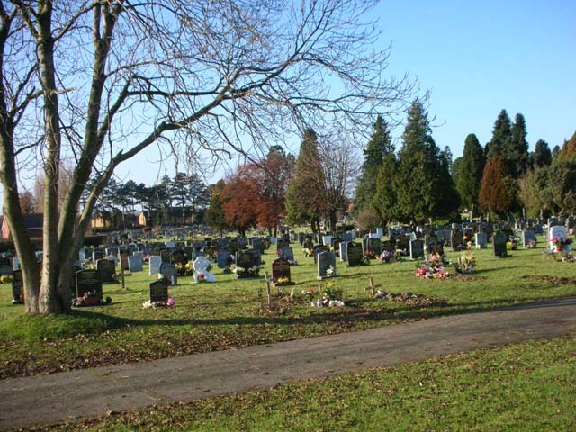

Memorial Safety Policy

Background

This policy has been produced to set out Irchester Parish Council’s position with regard to memorial safety, the responsibilities of the Council, its contractors, memorial masons and Deed of Grant Holders as well as the actions that will be taken to minimise risk to the users of Irchester cemetery.

History - Memorials have been erected on graves as a permanent reminder of those buried within. It is often wrongly assumed that memorials are permanent structures, installed to the highest standards, and will last forever without any need for repair.

Unfortunately, this assumption has cost the lives of six people nationally in recent years, most of whom have been children, and there have been countless accidents ranging from bruising to severe crush injuries and bone breakages.

Burial authorities have to tackle years of neglect and, in some cases, poor workmanship. Yet the memorials do not belong to the Parish Council; they remain the property of the person/s that has been granted the Exclusive Rights of Burial.

Responsibilities for Memorial Safety

The following parties have responsibility for memorial safety:

- The Council has health and safety responsibilities to its employees, contractors and visitors to cemeteries. The Council has a responsibility to staff (Section 2 Health & Safety at Work Act 1974) and a responsibility to visitors (Section 3 Health & safety at Work Act 1974). The Management of Health & Safety at Work Regulations 1999 places a legal duty on the Council to assess the risks from cemetery structures and work activities and ensure those risks are controlled

- A monumental mason has the responsibility to work in accordance with the Council’s conditions and specifications for memorials as laid down in the Parishes Cemeteries’ Regulations and in accordance with current standards available within the industry i.e. The National Association of Memorial Masons (NAMM) Code of Working Practice

- An owner, the Deed of Grant holder (or successor in title) of a memorial has the responsibility to maintain it so as not to present a hazard.

Notice of Intent

Prior to any memorials beings inspected, reasonable steps will be taken by the Parish Council to inform grave owners and members of the public of the intention to inspect memorials and remove the danger from unsafe memorials. This will involve:

  - Giving advance general notice in the Village Voice and/or
  - Making media announcements where appropriate
  - Publishing details on the Council’s website.
  - Placing information on the cemetery and parish noticeboards.

Assessment Process

The Council will risk assess and test memorials in accordance with the principles issued by the Institute of Cemeteries and Crematorium Management. The testing will be undertaken as part of a three year rolling programme. Memorials were last tested in November 2014. The safety assessment is to test whether memorials can withstand a reasonable hand force. This force has been arrived at scientifically and replicates the force of a person falling, pushing or pulling against a memorial.

Initial visual warning signs of memorial instability are as follows:
• Cracks in headstone or base
• Movement if rocked
• Ground settlement
• Waterlogged ground
• Missing parts

Reasons for memorial instability may include:
• Accidental damage
• Animal activity (e.g. burrowing by rabbits, moles, foxes etc.)
• Insect activity (e.g. ants nests)
• Encroaching tree roots
• Inadequate fixings
• Inferior materials
• Lack of maintenance
• Poor workmanship
• Subsidence
• Vandalism
• Weather/storm damage
• Decay through aging
• Weed killer chemicals

Safety assessments will be undertaken by council staff or external contractors who can show they have the required knowledge to undertake the testing.

After undergoing the testing process, memorials will be classified into three categories.

Category 1 – Requires immediate action. The memorials within this classification have been made safe by either staking and/or signage dependant on location within the cemetery. A memorial may be laid flat within the grave space where danger is acute and immediate and there is no other way of making safe. Laying flat will only be done as a last resort and, if possible, the inscription will be left visible.

Category 2 – Repair within six months. The memorials within this classification require remedial works within six months to ensure their long term safety. These include kerb and corners loose on kerbs, where there is movement of the memorial but passed the hand test. Also within this section are memorials that show movement/joints failed but lock during the inspection indicating an ‘earth anchor’ may be installed. These memorials require attention to ensure they comply with The National Association of Memorial Masons (NAMM) Code of Working Practice where all joints should be secure.

Category 3 – Pass. The memorials within this classification are considered to be stable and not dangerous in any way and are to be reassessed in three years.

Any memorial found to be unsafe whether staked or not will have a warning notice attached explaining the situation.

Methodology Stability Test

All memorials will initially undergo a visual inspection from safe distance whist the names and details of the interred are recorded. If the memorial passes the visual inspection the memorial will be assessed and approached from the front or a direction that will not place the inspector in danger if the memorial moves.

An initial fingertip test will be undertaken to establish stability of the memorial. A hand test as instructed by the Ministry of Justice Guidance (MoJ), National Association of Memorial Masons (NAMM) and Institute of Cemeteries & Crematorium Management (ICCM) will be carried out to confirm stability.

The inspection will be carried out front to rear for standard memorials. Kerb sets will be inspected by hand for secure fitting.

Records are to be made and updated at each stage.

Remedial Action

Due to the layout of the cemetery the risk of injury is classed as relatively low, so ‘make safe’ will be with the application of signs to warn owners and the public of unsafe memorials. The laying down of a memorial will only be undertaken as a last resort. Documentation and Recording Memorial assessments will be noted on record sheets. The information taken from the records will then be transferred to a computer database for long-term reference and security.

Notification, Repair and Re-fixing

Where a memorial has been identified as being unsafe and action taken to remove the immediate danger, the following actions as a minimum will be taken:
• Lists of failed memorials will be published
• Detailed lists of failed memorials will also be available for viewing
• A warning notice will be displayed and attached to any memorial that has been assessed as dangerous. Notices offering advice and contact information will be displayed on the Cemetery noticeboard.

In addition, where details of the grave owner are readily available a letter will be sent explaining the assessment process and the options available to them. Where a grave owner cannot be traced and, it is felt that the memorial is of historic significance or its maintenance is important to preserve the character or ambience of the Cemetery, the Council will consider carrying out the repairs subject to funds being available.

All repairs/re-fixings must comply with relevant industry guidance.

Future Installations

Although some deterioration to stonework, foundations and fixings due to weathering and the passage of time is inevitable, the Parish Council requires that in order to minimise these effects for all future installations memorial masons adhere to the National Association of Memorial Masons (NAMM) Code of Working Practice. This includes the use of appropriate foundations and fixings or other suitably approved and secure traditional methods for the installation of stone memorials as well as the relevant Cemetery Regulations currently in force.

Deed of Grant Holders

The assessment process may be upsetting for grave owners and visiting families. Irchester Parish Council regrets any distress that it may cause bit feel it is better that the memorial is assessed rather than it is left to pose a potential danger to others. . No attempt should be made to repair or remove any memorial except by a properly qualified memorial mason.

If a memorial has to be made safe grave owners can choose to either:

- Have the memorial repaired by arranging the necessary remedial work with an approved Irchester Parish Council memorial mason, for which the mason may charge a fee.
- Take no further action; if a stake has been used to support the memorial it is considered to be safe. The stake may be replaced to re-stabilise the memorial during further assessment in the next cycle of assessments to stabilise it.
- If the memorial has been laid flat this action will have been taken as a last resort. Once a memorial has been laid flat it is considered to be safe and can either be left in situ, removed or repaired by an approved Memorial Mason.

Points of Contact

Any concerns or questions about the memorial safety assessment process should be referred to the Registrar or the Clerk of the Council.

