
The Parish Council of Irchester
Clerk  Nikki Daft  45 Park Road  Irthlingborough  Northants  NN9 5PW |  | Telephone 07525909528  irchesterpc@gmail.com  www.hugofox.com/community/irchester-parish-council-13388/about-us

Dear Councillor 21st March 2023

You are hereby summoned to attend the ordinary meeting of Irchester Parish on Wednesday 29th March 2023 at 7.15p.m.at the Village Hall, School Road, Irchester

Yours faithfully
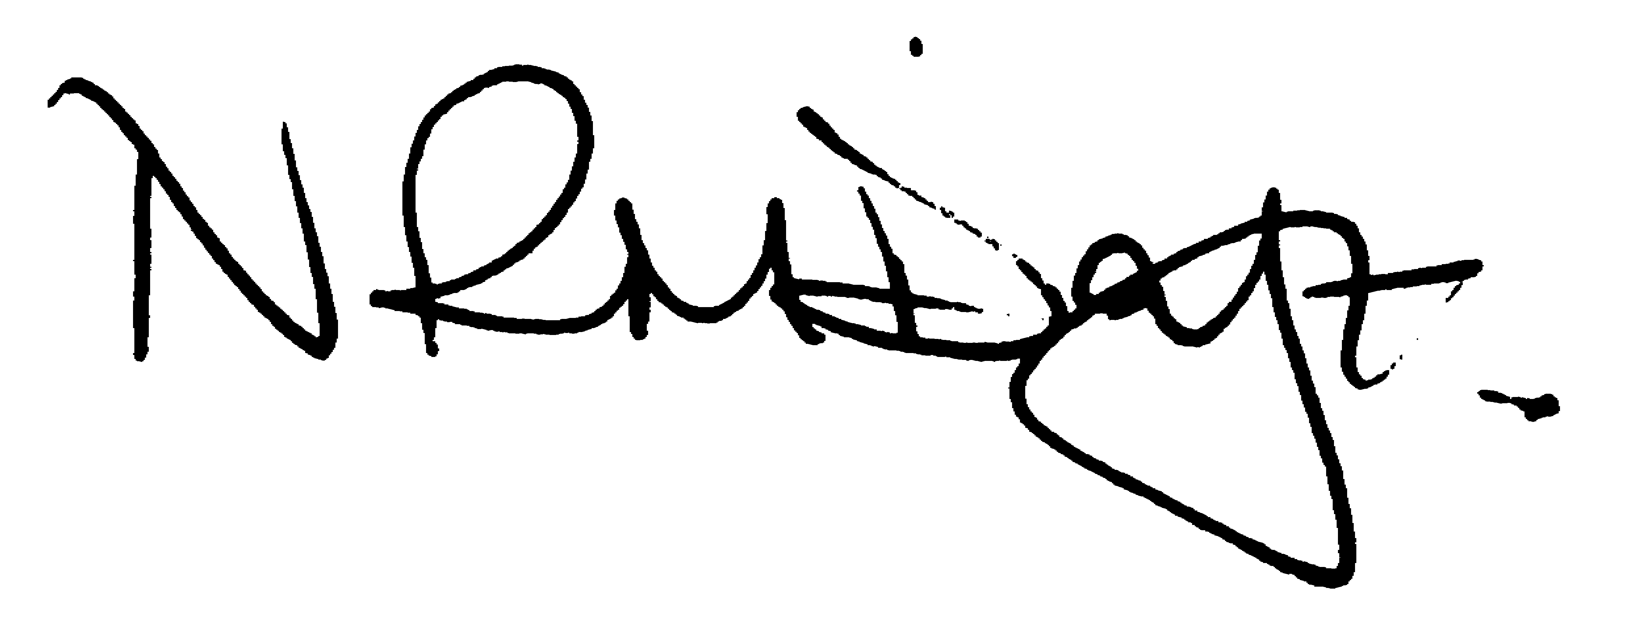

Nikki Daft – Parish Clerk

AGENDA

APOLOGIES AND ACCEPTANCE OF APOLOGIES

22/101 PUBLIC QUESTIONS, POLICE REPORT AND NNC UPDATE

Public are requested to send specific questions to council prior to the meeting due to time constraints

22/102 NOTIFICATION OF ANY DISCLOSABLE PECUNIARY INTERESTS OR OTHER INTERESTS
Only in respect of matters which are to be considered by members below. (Disclosures previously declared and registered need not be repeated).

- To receive declarations of interest
- Councillors to declare any personal interest in any items on the agenda
- Councillors to declare any personal and/or prejudicial interest in any items on the agenda and to inform the Chairman if they wish to speak on the matter during public participation

22/103 MINUTES

a) To approve the minutes of the meeting held on 22nd February 2023 as a true record.

22/104 FINANCIAL/POLICIES

- To Approve Payments for March (RFO)
- To receive information regarding the current financial statement (RFO)
- To agree the authorisation of the bacs payments
- To discuss the quotations for the energy costs for the street lights

22/105 CEMETERY/WAR MEMORIAL

- To receive an update on cemetery matters

22/106 HIGHWAYS

- To receive an update on any Highways issues
- To receive recommendations from the Highways Working Party regarding traffic calming for the village
- To discuss the cost to replace the street light in Sharwood Terrace
- To receive the response from the PO regarding the installation of a post box on the corner of Wollaston Road and School Road

22/107 PLAY AREAS

- To receive an update regarding the play areas
- To discuss the replacing of the dog bin on the Recreation Ground

22/108 COMMUNITY

- To receive a report from the community orchard.(KW)
- To receive an update on the library.(JPC)
- To discuss events for the Kings Coronation (JPC)
- To discuss the placing of a new bench opposite the war memorial
- To discuss signing the Armed Forces Covenant

22/109 PLANNING

- NW/23/00127/FUL Proposed single storey side extension. 6 Woodlands Road, Irchester
- NW/23/00145/FUL Internal alterations and extensions, conversion/rebuilding of out buildings to kitchen, conservatory, front porch and new retaining wall – 109 High Street Irchester

22/110 CORRESPONDENCE

To discuss items required for the next agenda.

22/111 EXCLUSIVE TO PUBLIC AND PRESS

To agree to discuss the following item exclusive to public and press

22/112 UPDATE ON AUSTIN CLOSE PROMOTION AGREEMENT

To discuss further information regarding the proposed promotion agreement

