
The Parish Council of Irchester
Clerk  Nikki Daft  45 Park Road  Irthlingborough  Northants  NN9 5PW |  | Telephone 07525909528  irchesterpc@gmail.com  www.hugofox.com/community/irchester-parish-council-13388/about-us

Dear Councillor 20th May 2024

You are hereby summoned to attend the Annual meeting of Irchester Parish Council followed by the ordinary meeting of the Parish Council to be held at Village Hall, School Lane, Irchester on Wednesday 29th May 2024 at 7.15p.m.

Yours faithfully
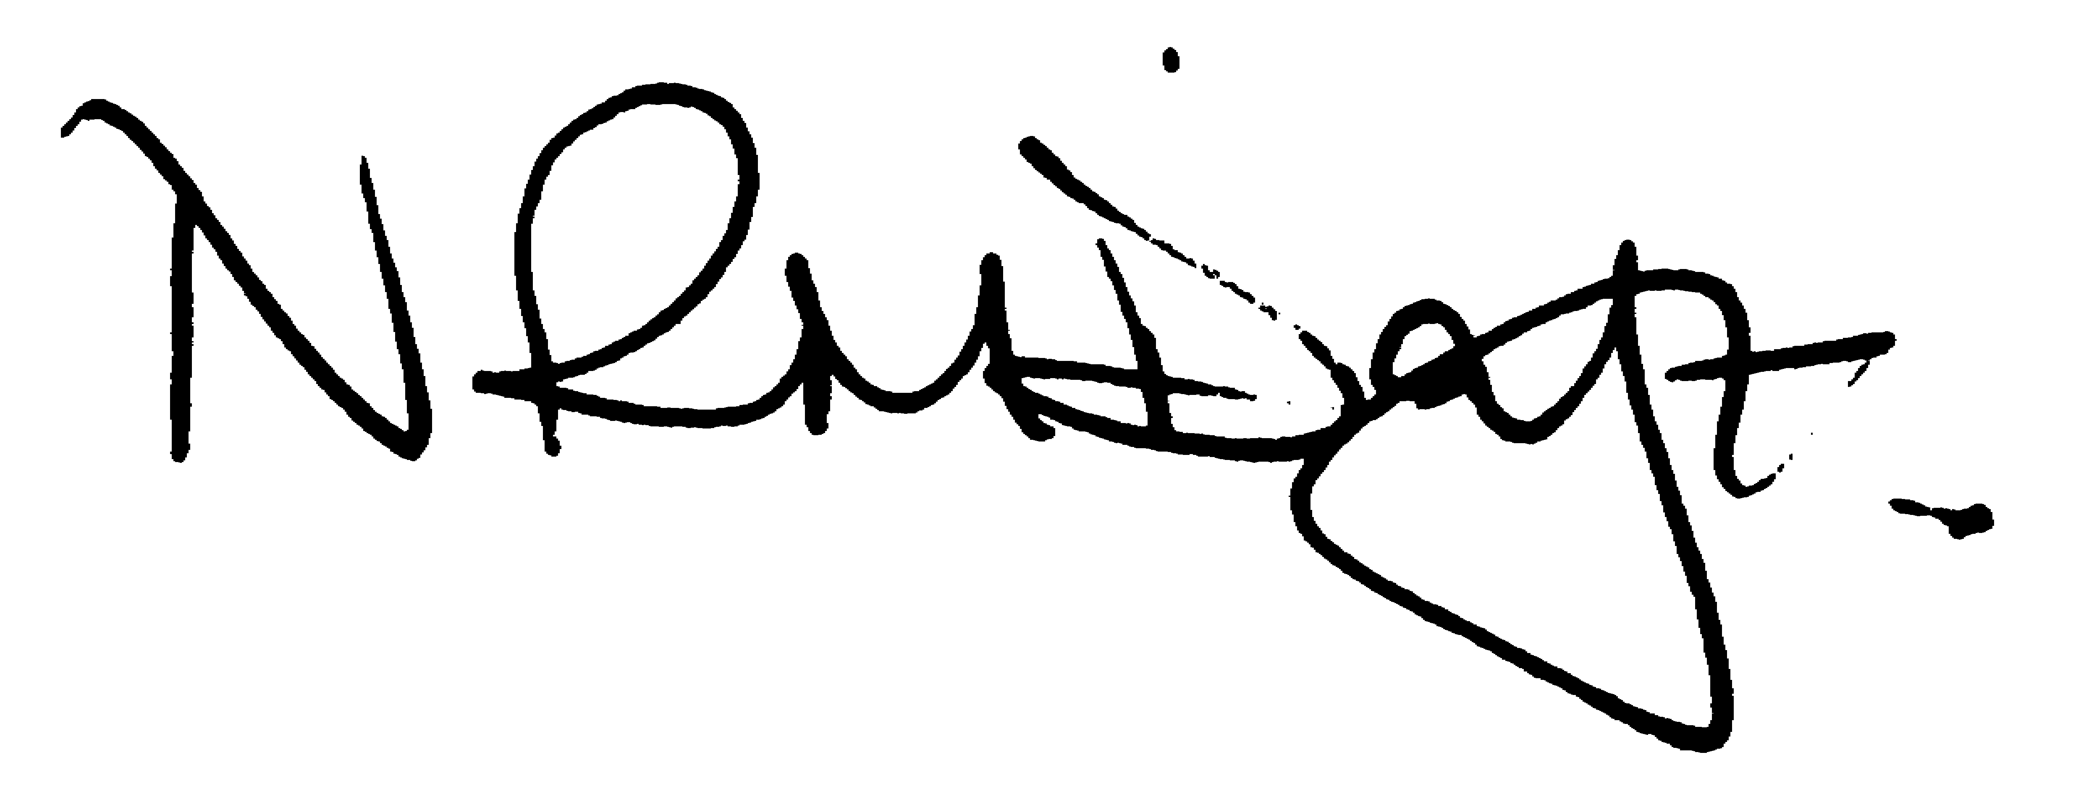

Nikki Daft – Parish Clerk

AGENDA

APOLOGIES AND ACCEPTANCE OF APOLOGIES

24/1 CHAIRMAN ELECTION AND ACCEPTANCE OF OFFICE

- To receive nominations and elect a Chair for the Parish Council for the ensuing year. Declaration of acceptance of office to be completed.

24/2 NOTIFICATION OF ANY DISCLOSABLE PECUNIARY INTERESTS OR OTHER INTERESTS
Only in respect of matters which are to be considered by members below. (Disclosures previously declared and registered need not be repeated).

- To receive declarations of interest
- Councillors to declare any personal interest in any items on the agenda
- Councillors to declare any personal and/or prejudicial interest in any items on the agenda and to inform the Chairman if they wish to speak on the matter during public participation

24/3 APPOINTMENTS OF MEMBERS to the following specific areas of interest:

a) Vice Chair b) Internal Accounts Controller (not bank signatory)
c) Footpaths d) Highway Wardens for Irchester, Little Irchester and Knuston
e) H & S Representative

24/4 ADVISORY GROUPS/WORKING PARTIES

To approve the following:

Groups below to be set up as and when required:

Recreation Cemetery Highways and Lighting Orchard

The following established Working Parties

- Finance, Staff & Policies – Members being Chair, Vice Chair, Cllrs JP Carr & D Shroll – role to advise council on staffing issues, policies new and updates, monitor finances throughout the year and look at budgets prior to full council. – 1 vacancy
- Planning – Members being Chair, Vice Chair, Cllrs JP Carr, & J Dunkley – 2 vacancies – role to look at the planning applications and advise council on planning policies.
- Emergency planning/flooding – Members being Chair, Vice Chair & Cllrs P Smith – 2 vacancies – role to update emergency plans as and when required.
- Community Projects – Members being Chair, Vice Chair, Cllrs Carr, – 2 vacancies – role to recommend, organise and cost projects.
- Village Magazine – Members being Chair, Vice Chair, JP Carr & 1 MOP –1 vacancy – role to produce and distribute the Parish Magazine

New Working Parties

- Youth Council – role to investigate and set up a Youth Council
- AI and Technology – role to investigate how AI and Technology can help the council in the future and make better communication with residents.

24/5 APPOINTMENT OF REPRESENTATIVES ON OUTSIDE BODIES

To appoint representatives on Outside Bodies - the role being to attend committee meetings as an observer ,if able to, answer questions relevant to the council, or bring back to the council, any questions or queries the committees may have.

a) Irchester Sports Association (2) b) Village Hall Committee
c) Youth Centre Management Committee d) Allotment Association
e) Bowling Club Committee f) Library

24/6 DATES OF COUNCIL MEETINGS 2024/25

To approve the dates for meetings throughout 2024/25

26th June 2024 28th August 2024 25th September 2024 30th October 2024
27th November 2024 29th January 2025 26th February 2025 26th March 2025
30th April 2025 Election year 14th May 2025

To commence the Ordinary Meeting of Irchester Parish Council

24/7 PUBLIC QUESTIONS, POLICE REPORT AND NCC UPDATE

Public participation may continue until for 15 minutes after which the public must not take part at any other time during the meeting. Request should be made to the Chair if any member of the public wishes to make a recording of any part of the meeting. All audible sounds to be switched to silent unless otherwise agreed at the start of the meeting. A report only can also be given by the Police and NCC representatives

24/8 MINUTES

- To approve the minutes of the meeting held on 24th April 2024 as a true record

24/9 CO-OPTION

To receive co-option details

24/10 FINANCIAL/POLICIES

- To Approve Payments for May 2024 (RFO)
- To receive information regarding the current financial statement (RFO)
- To agree the authorisation of the bacs payments
- To agree bank signatories for the following year
- To review the financial risk assessment, standing orders and financial regulations

24/11 RECREATION GROUNDS

- To receive an update regarding the recreation facilities

24/12 HIGHWAYS

- To determine highways issues to be added to the next agenda
- To discuss a request from residents for a memorial bench
- To discuss the quotation for the repair of the bench near to the water tower Farndish Road

24/13 CEMETERY/WAR MEMORIAL

- To receive information regarding the cemetery

24/14 PLANNING

- NW/24/00255/FUL – Demolition of garage and store and erect new ones – 20 Roman Way
- NW/24/00244/LBC – Repointing Blacksmiths Cottage – 57 High Street
- NW/24/00174/PAS - Prior approval proposed for installation of a PV array on the roof of an existing B1(c), B2 and B8 class building. Location: 15 - 23 Claudius Way Irchester

24/15 CORRESPONDENCE

To consider information received from incoming correspondence and decide on agenda items for the next meeting.

