
The Parish Council of Irchester
Clerk  Nikki Daft MILCM  45 Park Road  Irthlingborough  Northants  NN9 5PW |  | Telephone 01933384180  Parishclerk123@gmail.com

Dear Councillor March 2017

You are hereby summoned to attend the Ordinary meeting of Irchester Parish Council to be held in the Village Hall School Road Irchester on Wednesday 29th March 2017 at 7.15p.m.

Yours faithfully
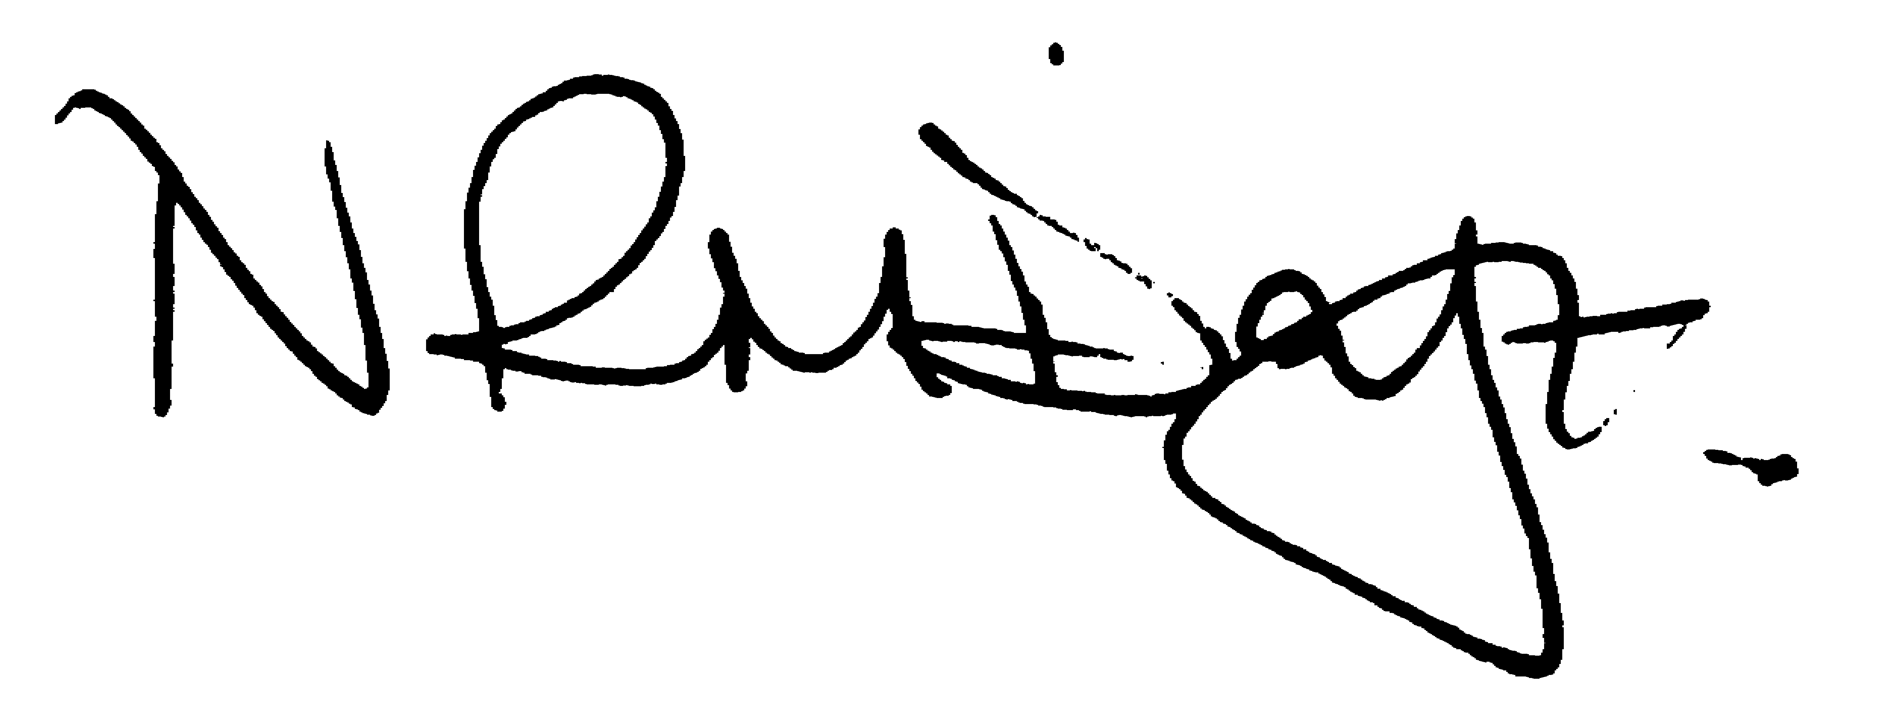

Nikki Daft – Parish Clerk

AGENDA

APOLOGIES AND ACCEPTANCE OF APOLOGIES

16/114 NOTIFICATION OF ANY DISCLOSABLE PECUNIARY INTERESTS OR OTHER INTERESTS
Only in respect of matters which are to be considered by members below. (Disclosures previously declared and registered need not be repeated).

16/115 PUBLIC QUESTIONS, POLICE REPORT AND NCC UPDATE

Public participation may continue until for 15 minutes after which the public must not take part at any other time during the meeting. Request should be made to the Chair if any member of the public wishes to make a recording of any part of the meeting. All audible sounds to be switched to silent unless otherwise agreed at the start of the meeting. A report only can also be given by the Police and NCC representatives

16/116 MINUTES - To approve the minutes of the meetings held on 22nd February 2017 as a true record

16/117 RESOLUTIONS AND ACTIONS - MATTERS FROM PREVIOUS MINUTES

- Letter to Orbit
- Letter Norse re rubbish Lt Irchester
- NCC footpath
- Cemetery letter/deed changes implemented
- Letter re land Gypsy Lane land owner
- Solicitor appointment

16/118 FINANCIAL/POLICIES

- To Approve Payments for March 2017 (Clerk)
- To receive information regarding the current financial statement (Clerk)
- To agree the authorisation of the bacs payments
- To look at banking schemes
- Letter from the school re Patrol Crossing Person
- To discuss the proposals/changes and launch of 3 year Business Plan

16/119 RECREATION GROUNDS

- To receive and agree the reports/repairs/damage to the recreation grounds (JD)
- To discuss the repair of the roundabout in the recreation ground
- To discuss the request from Tyanna Circus to attend the village in July/August for a week and at what cost.
- To discuss the request from Scarrott Fair to attend the village on 15th to 22nd May and at what cost
- Request from Sports Club to use the recreation ground for parking on Sunday 9th April 2017

16/120 HIGHWAYS

- To agree any items that need to be added to the next agenda
- Street Doctor response
- To receive an update re applying for a definitive footpath.
- To discuss the TR22 lighting report and receive a quotation regarding repairs.

16/121 LITTLE IRCHESTER/KNUSTON - To agree the Highway Warden report, previously circulated. Matters arising will be added to the next agenda

16/122 PLANNING - To discuss any planning issues

- WP/17/00144/FUL change from shop to residential – 2 Wollaston Road
- WP/17/00115/FUL 2 storey side extension – 16 James Street
- WP/17/00120/FUL – Single storey side extension – 63 Saxon Rise

16/123 NEIGHBOURHOOD PLAN - To receive an update on the progress of the NHP

16/124 CEMETERY/WAR MEMORIAL

- To receive the Registrars report and decide if details should be added to the next agenda

16/125 COMMUNITY ISSUES

- To discuss the progress of the land registered to the council
- To discuss the purchasing of village flags at a cost of £67.50 each for 5 or £81.00 each for 2 plus £18.00 delivery charge
- To discuss the details required for the new pc website

16/126 CORRESPONDENCE To consider information received from incoming correspondence and decide on agenda items for the next meeting.

- NCC consultation Transfer of the Village Green at Keats Way, Rushden to Rushden Town Council
- Invite to The Mayor Grand Masquerade Ball

